LESSON STUDENT COORDINATES
Name _____________________________________
Directions: Listed below
(1) PROBLEM: Place a number value on the coordinate place below. The person using your lesson will then write the value specified in your table listed. Locate the value of each number in the coordinates provided and write that number in the space specified for problem 1.
(2) PROBLEM: The second part of this lesson you will then have the student add- subtract – multiply or divide the numbers you have placed in each coordinate. After completing Part 1 the person using this lesson will then solve each mathematical problem listed in part 2.
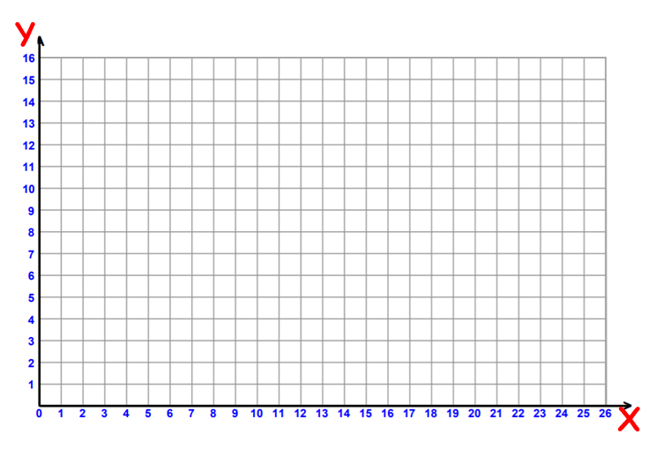

- PROBLEM Write the value of the number in the coordinates that are provided.
A ( , ) _____ | D ( , ) ____ | G ( , ) ___ | J ( , ) ____
B ( , ) ___ | E ( , ) ____ | H ( , ) ___ | K ( , ) ___
C ( , ) ____ | F ( , ) ____ | I ( , ) ___ | L ( , ) ___
- PROBLEM Add up the value in the letters provided from the coordinates above and place the total in the space listed.
= ____ | = ____ | = _____ | = ____
= ____ | = ____ | = _____ | = ____
= ____ | = ____ | = _____ | = ____

