Name: Lesson Student Coordinates

Directions: You need to design two parts to this lesson. Part (1) places the coordinates for A through F so the person using this lesson may place the dots where you specified. Part (2) Provide the letters G through M allowing the person to write the coordinates you have placed on part 2 coordinate plane.

Introduction to the Coordinate Planes and Graphing
A point on a two dimensional graph is named by an ordered pair. An ordered pair is a pair of numbers for which the order of the numbers is important. The first number in the pair represents the x-coordinate and the second represents the y-coordinate. An ordered pairs is used to represent a point on a coordinate plane. A coordinate plane is formed by two real number lines intersecting at a right angle. The horizontal number line called the x-axis and a vertical number line called the y-axis. The point in which theses axes intersect is the origin. The origin has the ordered pair (0, 0). These two axes spilt the plane into 4 regions called quadrants. The quadrants are numbered starting with the top right region as Quadrant I and go counter-clockwise labeling the quadrants. The quadrant numbers are always roman numerals.

To plot an ordered pair, go in the direction of the sign (right/up for positive, left/down for negative) the number of spaces. If a number is the x-coordinate the choices are either right, left or stay. If the number is the y-coordinate, the choices are either up, down or stay. Any ordered pair that has a zero for the y-coordinate will be located on the x-axis. Likewise, if the y-coordinate is zero, the point will be on the x-axis.

1) Plot the given ordered pairs. 2) Using the coordinate plane given below, write
(Label with the designated letter) the ordered pairs for each point.
A( , ) B( , ) G( , ) H( , )
C( , ) D( , ) J( , ) K( , )
E( , ) F( , ) L( , ) M( , )
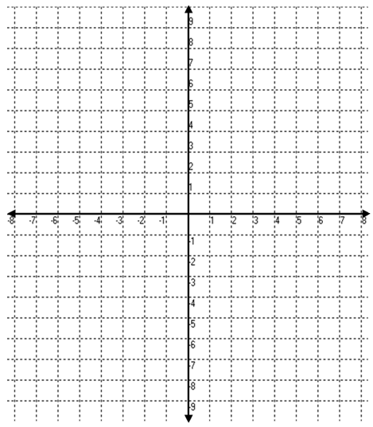
PART 2
PART 1

