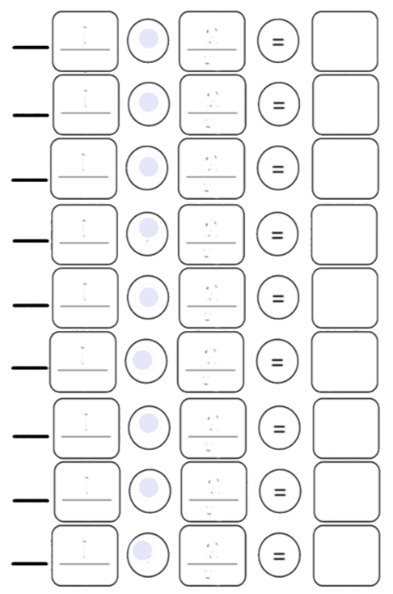
LESSON STUDENT TOP-SECRET CODE
NAME ______________________
Directions: Solve the math problems to crack the top secret code. Place the letters above the number that you completed.
Scan the QR Code to check your answers.

