Lesson – Students Cross-number Puzzle
ACROSS | DOWN
Become your own author.
Name ________________________

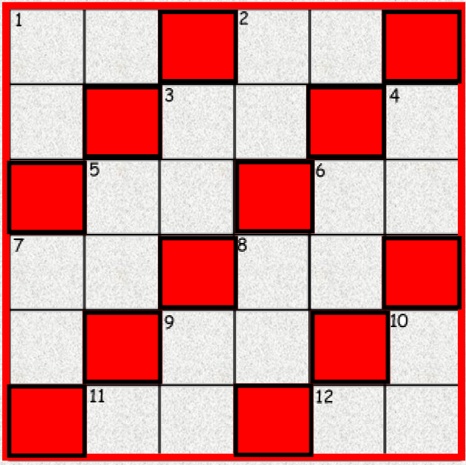
ACROSS |  |  | DOWN
1.  2.  3.  5. | 6.  7.  8.  9. | 11.  12. | 1.  2.  3.  4.  5. | 6.  7.  8.  9. | 10.

ANSWERS:
The answers are to the left and are flipped upside down. Do not look at the answers until you have completed the puzzle.

