Name
Class
Date

10-7

Areas of Circles and Sectors



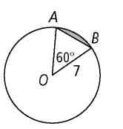
Find the area of each of the following. Leave your answer in terms of π.
1. O 2. AOB
3. sector AOB 4. the shaded segment
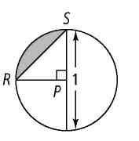

Find the area of each of the following. Leave your answer in terms of π.
5. P 6. RPS
7. sector RPS 8. the shaded segment

Find the area of each shaded sector of a circle. Leave your answer in terms of π.

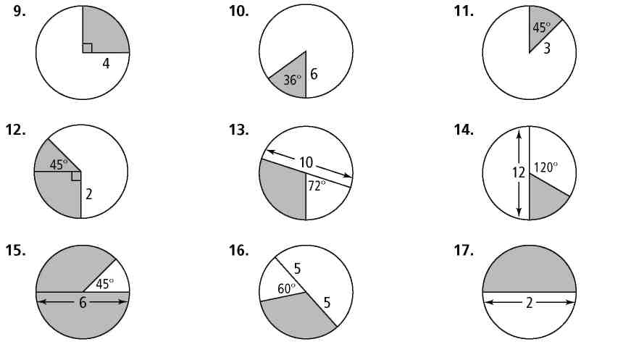
9. 10. 11.

12. 13. 14.

15. 16. 17.

Name
Class
Date

10-7
Areas of Circles and Sectors
Practice (continued)
Form G

Find the area of sector RST in S using the given information. Leave your answer in terms of π.
22. r = 3 in., = 30 23. r = 8 mm, = 90

