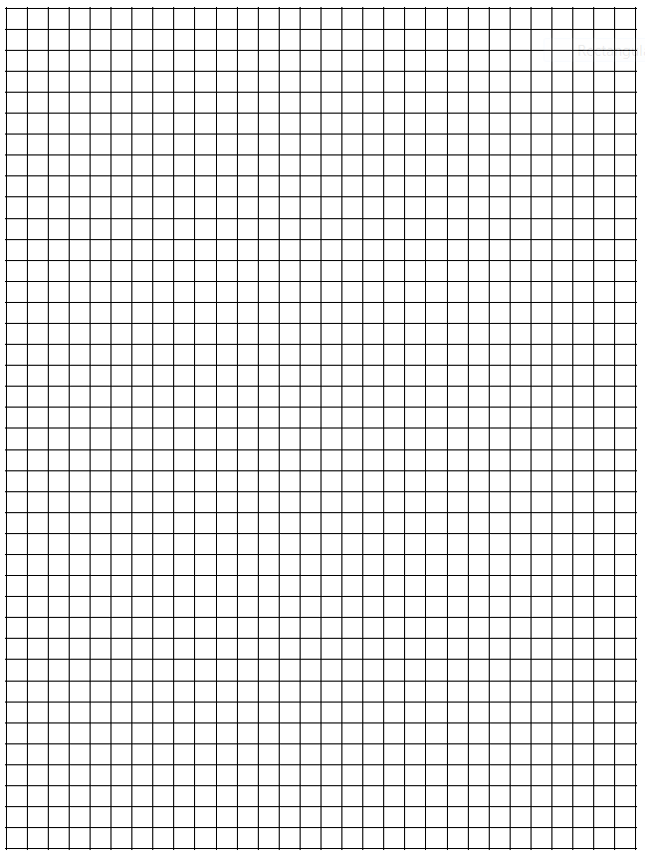
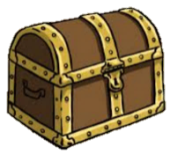
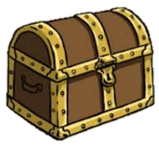
N

E

W

S

Name ______________
This lesson will work with addition-subtraction-multiplication-division-algebra
Lesson Math & Map
- GO  Directions: Find the correct treasure chest. Start from the circle in the middle and follow your way around the map using the clues that you will obtain from the equations written on the right.  If you are designing this lesson you may place the treasure chest anywhere you like prior to placing your equations.  - GO  - GO  - GO  - GO | 6.)GO  7.)GO  8)GO  9)GO  10)GO
EXAMPLE: math problems 1.) GO EAST 8 + ___ = 12 6.) GO NORTH 5 X ____ = 40

