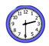 | 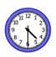 | 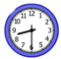 | 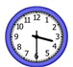
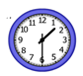 | 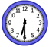 | 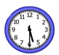 | 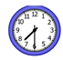
1:30
2:30
3:30
4:30
5:30
6:30
7:30
8:30
Name: __________________________

