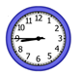 | 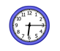 | 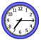 | 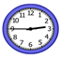
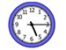 | 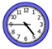 | 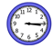 | 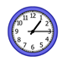
1:15
2:45
3:15
4:45
5:15
6:15
7:15
8:45
Name: __________________________

