Lesson on Living and Living and Non-Living Things
Name :
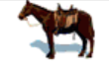 | 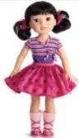 |  |  | 
 |  |  |  | 
 |  |  |  | 
 | 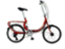 |  |  | 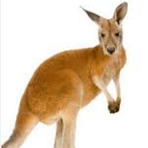
Click and move the pictures to the column they belong in
LIVING | NON LIVING | LIVING | NON LIVING

