NAME:
Lesson on Halloween Move pictures to the correct table
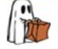 | 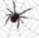 | 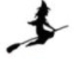 | 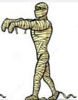
 | 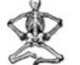 | 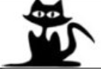 | 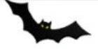

BLACK  CAT |  | BAT
PUMPKIN |  | GHOST
SKELETON |  | SPIDER
WITCH |  | MUMMY

