Examine each state outline. Write the correct name of each State in the United States in the space next to the corresponding outline. If you need help, highlight the “hint” box and clues about the country will appear to guide you. Good Luck! Name _________

STATE OUTLINE | NAME OF STATE | HINT
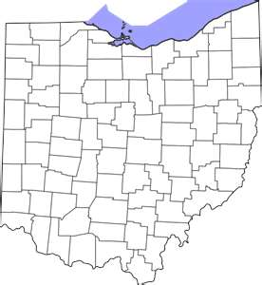 |  | This state is where you live.  The capital is ColumbusBogota
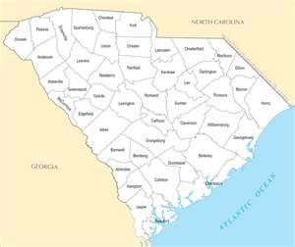 |  | This state is where Myrtle Beach is Located.  The capital is Columbia
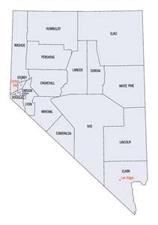 |  | This state is located in the west. Many people travel to Las Vegas.  The capital is Carson City
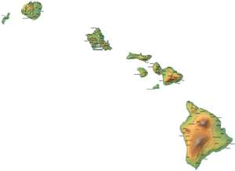 |  | This State is located in the west.  The capital is Honolulu
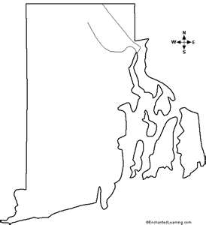 |  | This state is located on the East Coast.  The capital is Providence
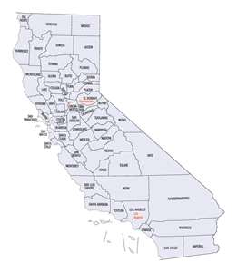 |  | This State is located on the West Coast.  The capital is Sacramento
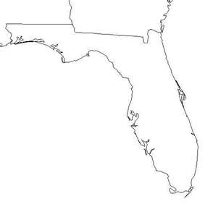 |  | This State is in the South East.  The capital is Tallahassee
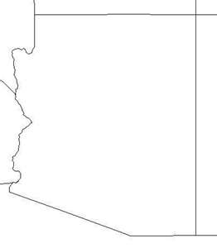 |  | Popular desert state in the south that retirees are flocking to.  The capital is Phoenix
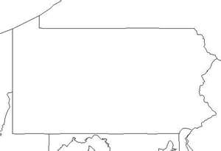 |  | This state is located to our east.  The capital is Harrisburgh
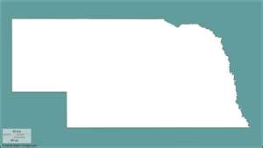 |  | This state is located in the center and is landlocked. The cornhusker state.  The capital is Lincoln
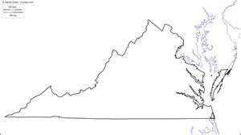 |  | Beautiful east coast state.  Richmond is the capital.
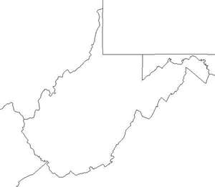 |  | This state is south of us, we travel thru its windy roads on the way to the beach.  The capital is Charleston
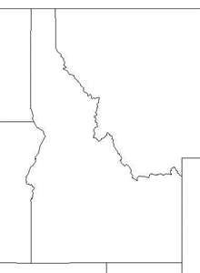 |  | This state is known for their potatoes.  The capital is Boise

