Name
My Story

This is a picture about how I was playing in the pond with my two sisters and dog.

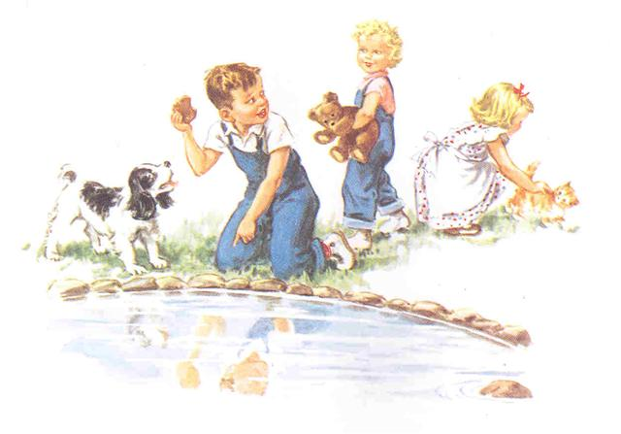
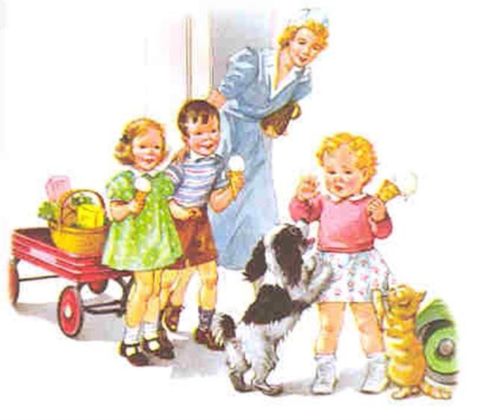
This is story about the picture of how we all went to get ice Cream.

