**Your name __________________________ Lesson 17**

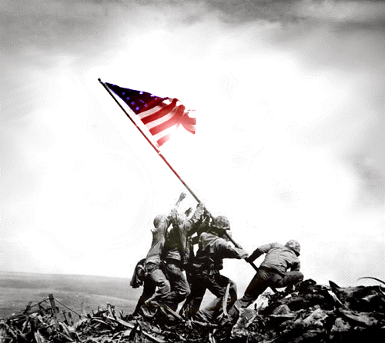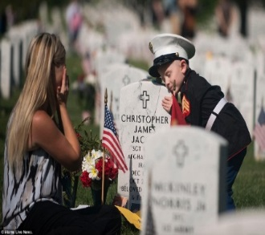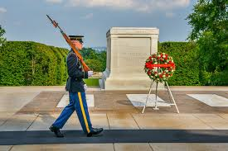**Directions: Write a paragraph about each photo posted in reference to Veterans day.**

