Taking Care of Teddy

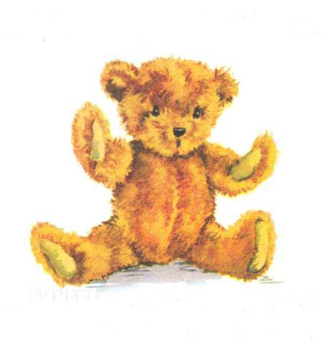

Author Susie Hershberger
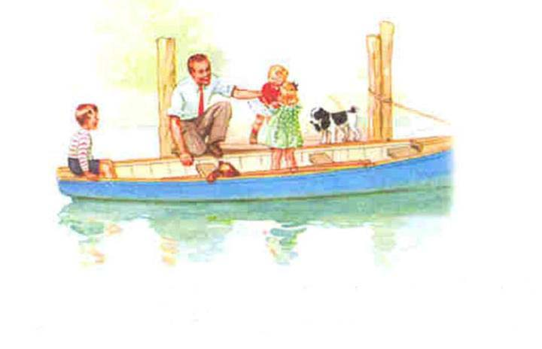
One day Dad took Peg, John and Molly to the pond. Flip and Teddy came along too.

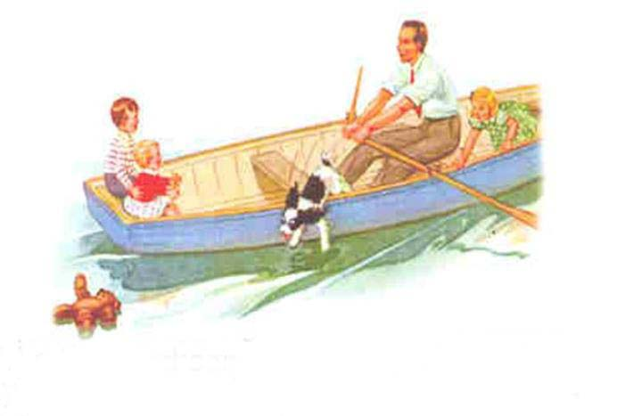
As Dad rowed the boat, Molly and John sat on the bench. But soon, Molly forgot about Teddy. Oh, no! Teddy fell into the water.
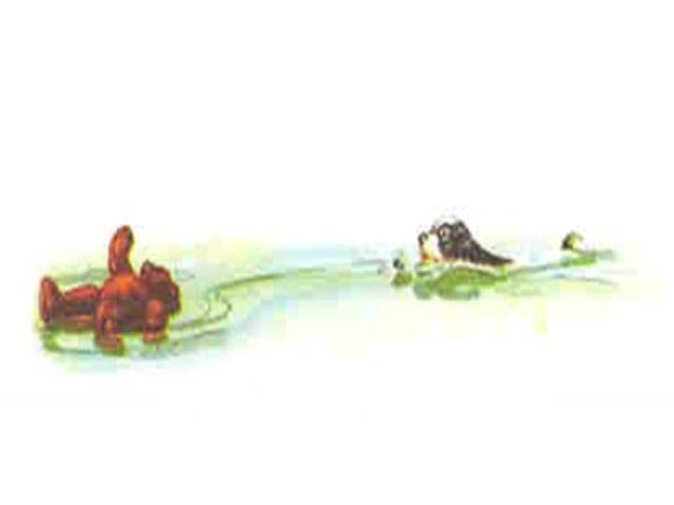
Flip swam towards Teddy. Can Flip get Teddy before he sinks into the water?

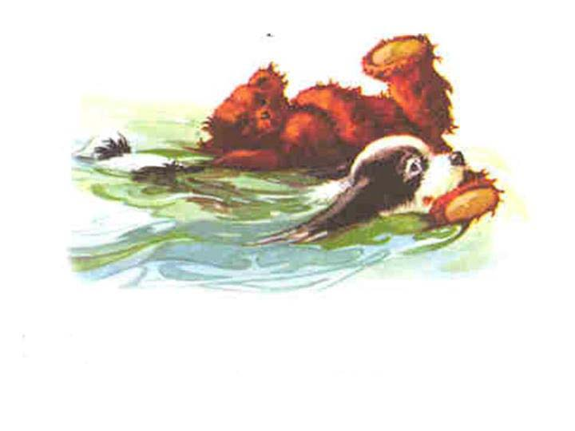
Flip grabbed Teddy’s foot. Then he dragged him back to the boat. Soon Flip had Teddy back to Molly.
Molly took Teddy in her arms. She was so happy to see Teddy she squeezed him tight.
Later, she sat on the bench in the park and held onto Teddy for a long time. She didn’t want to lose him again.

The End

