QR Challenge:
Technology Riddles Scavenger Hunt

QR Codes for Teachers: Use the 'instructions' code to start the lesson. Place the 'Quiz Questions' around the school. I will leave this as a word document not a PDF file so that you may adjust the hunt anyway you want.

Where the students are to go next after they read the code may need to be changed on some of the codes so that they apply to your school or classroom. You will need to make a new QR code if that is the case but you can still use the riddle
Instructions
Technology Riddles Scavenger Hunt Your job is to find the QR codes which your teacher has put on display around the area. Scan each QR code into your mobile device to get a challenge question. Record the correct answers to all of the *16* questions. The winner is the student with the most correct answers at the end of the time available. Good luck!
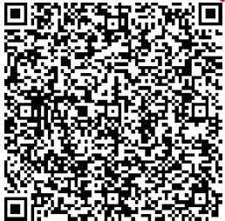
.

Instruction Code for students to follow

