Teacher’s Daily Five
Tracking Sheet

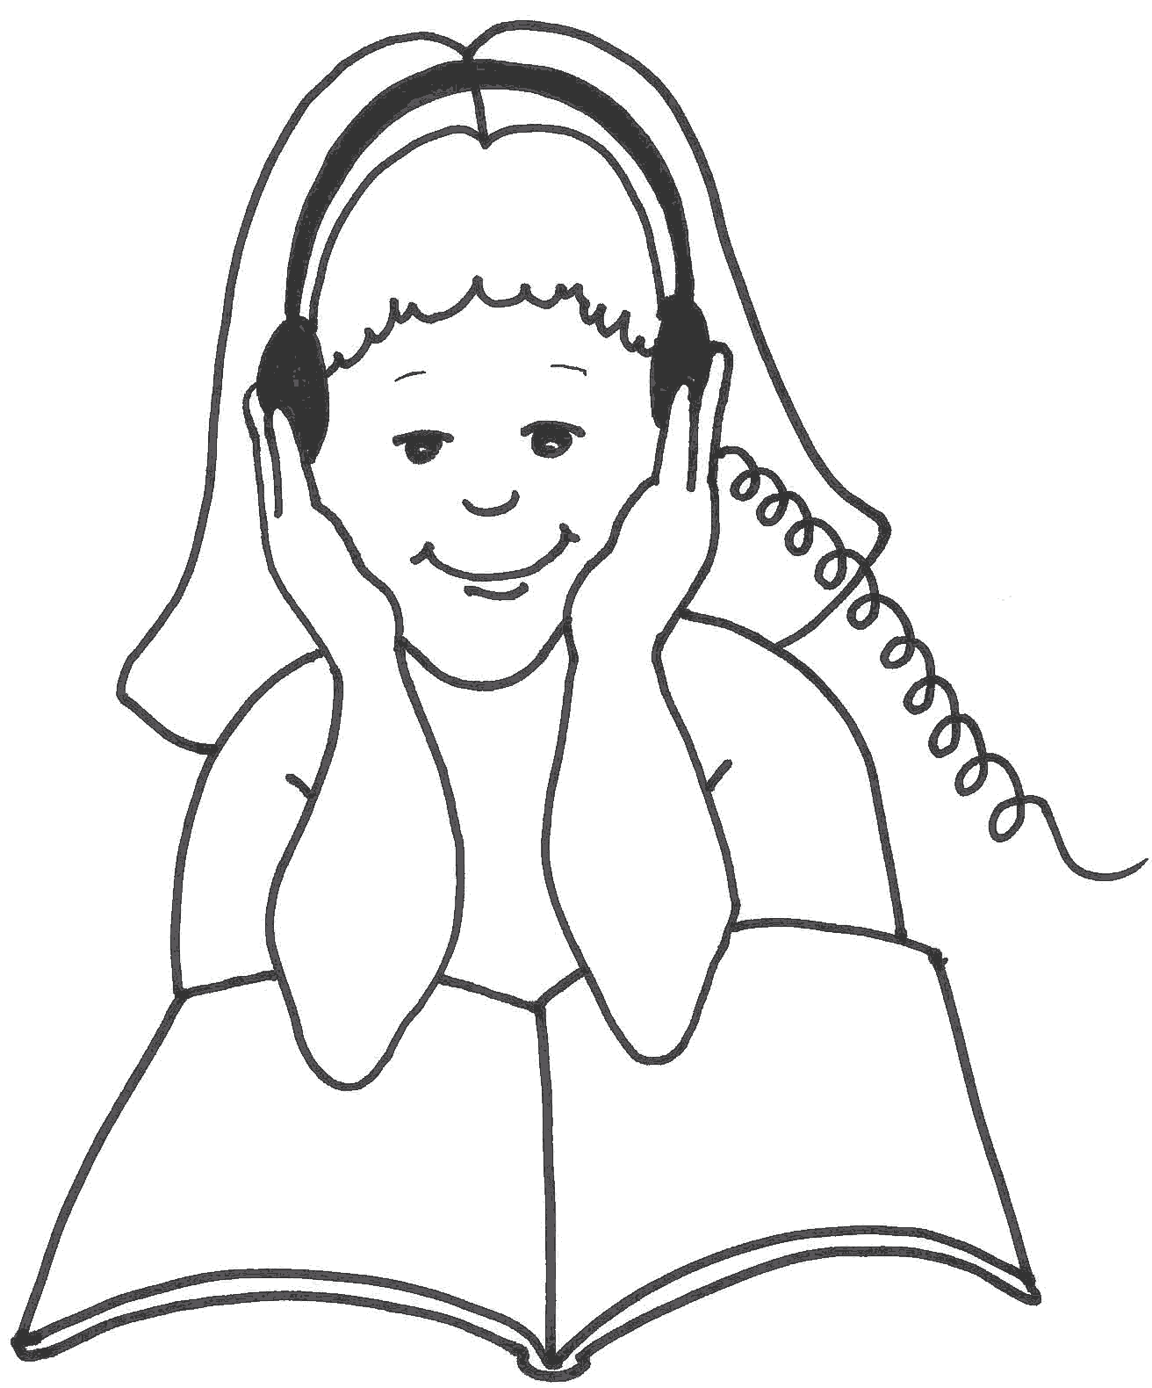  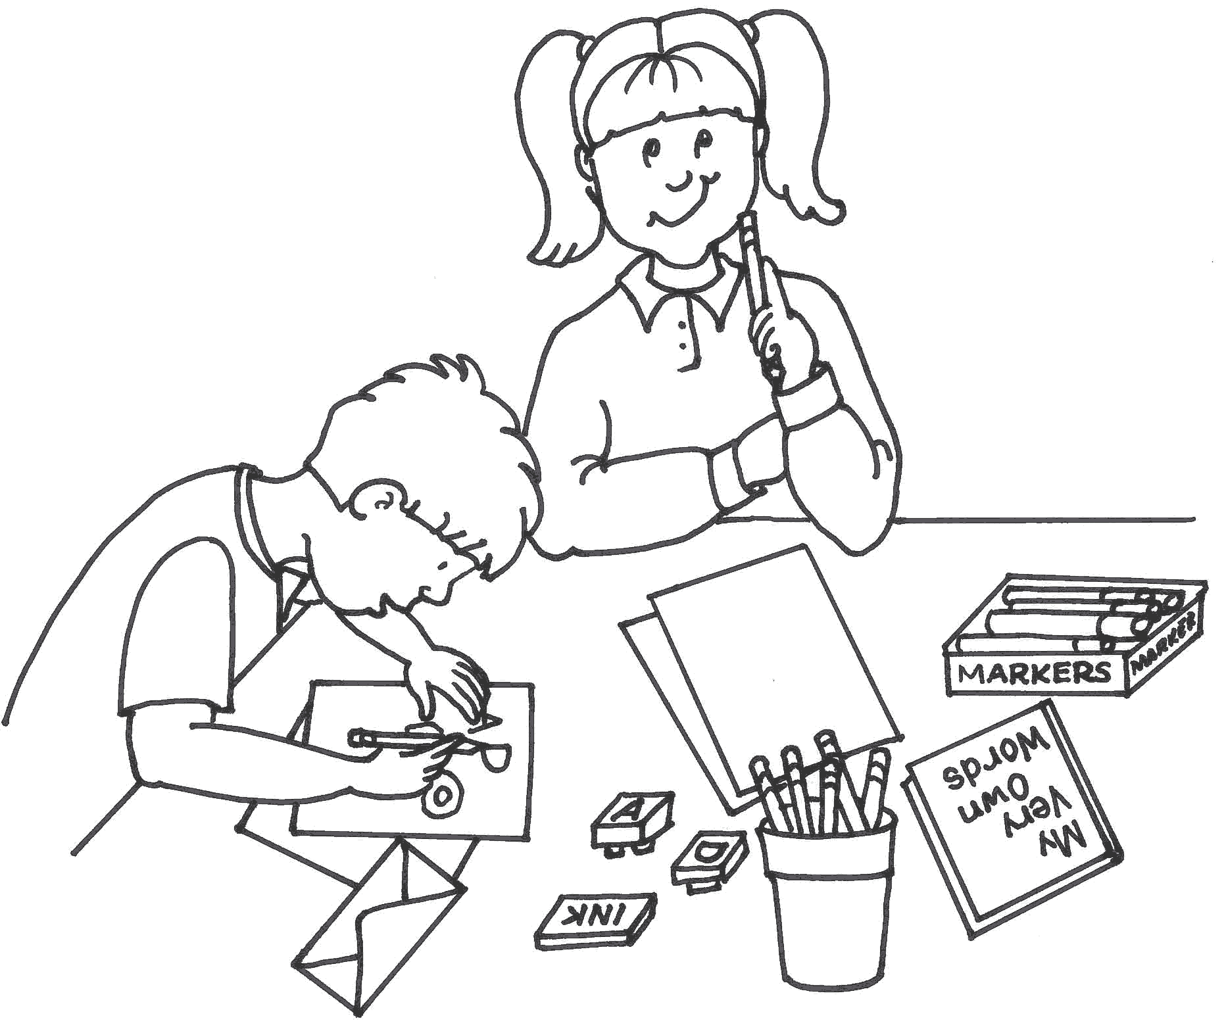 | Monday |  |  |  |  | Tuesday |  |  |  |  | Wednesday |  |  |  |  | Thursday |  |  |  |  | Friday
 | Read to Self | Read to Someone | Listen to Reading | Work on Writing | Word Work | Read to Self | Read to Someone | Listen to Reading | Work on Writing | Word Work | Read to Self | Read to Someone | Listen to Reading | Work on Writing | Word Work | Read to Self | Read to Someone | Listen to Reading | Work on Writing | Word Work | Read to Self | Read to Someone | Listen to Reading | Work on Writing | Word Work

