I make connections between different things I read using prior knowledge.  text to text text to self text to world  How did my connections help me understand the  text? C | - I ask questions about the story before,  during, and after reading  - I wonder... I was confused when...  How could that be? Why do you think?  Who... What... Where... When...  - QAR  C
I see what I read.  I feel what I read.  It's like a movie in my mind.  C | Dig through the text.  - The text was mostly about...  - The author is trying to tell us that...  - I learned...  - The important details were...  C

- I use clues, illustrations, and captions from the text to figure out or guess what is really happening.  - I can support my inference with evidence.  C | - I asked what are the Key Ideas/Points?  - Characters, Setting, Problem, Solution  - My retell is in sequence (First, Next, Last)  C
- Wait a minute that doesn’t make sense, I should…  - Summarize, adjust my rate, reread, read on, skim and scan, ask for help  - Who is the story about?  - What is happening in the story?  - What is the author trying to tell me? E | - I am a voracious reader because I read, read, read, as much as I can so I can learn more words and be a better reader!  E

It’s as easy as PIE!  P-Persuade-to convince a reader of a certain point of view  I- Inform-to give information to the reader  E-Entertain-to provide enjoyment to the reader  A | - I choose a book based on:  - Purpose – Why do I want to read it?  - Interest – Does it interest me?  - Comprehension – Am I understanding what I read?  - Knowledge – Do I know most of the words? A
- Interesting words and use new vocabulary in my speaking and writing.  E | - I understand and read a variety of genres  - I know how the genre of a text affects the way I will read it.  A

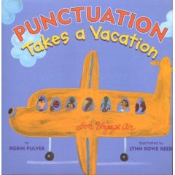  - I use punctuation to enhance phrasing and prosody.  - End marks, quotes, commas,  paragraphing, etc. F | - I adjust and apply different reading rates to match text and audience.  - I might run, walk, or jog, as appropriate.  F
I can tell the difference between facts and opinions in text.  I recognize propaganda.  Look for key words like:  Maybe probably  Most likely best/worst  I think I believe  C | I can compare and contrast within AND between texts.  - Comparison refers to how two things are alike. (similar, also, too, like, both)  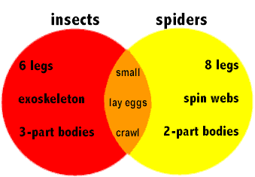  - Contrast refers to how the two things are different. (however, but, different, unlike, on the other hand)  C

- I stop often and ask  - Who did I just read about?  - What just happened?  - Do this after a sentence, paragraph, a page, a chapter.  C | - What might happen in the story?  - Were your predictions true, partially true or way off?  - Change predictions as you gain more information.  - Use pictures, words, background knowledge. C
- Characters-Do they change throughout the story?  - What is the setting? Is it stated or inferred?  - What is the problem and how was it resolved?  - Where was the Climax? (most exciting part)  - Theme-What is the underlying message?  C    - I paint a picture of the most important information from the selection.  - What information is essential to understanding what is going on?  C | 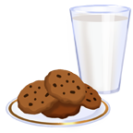  - Events happen (effects), along with the reason why they happened (causes)  - Look for clue words as to what has happened.  - because, if, then, since, so, therefore, as a result of  - If you Give a Mouse a Cookie he will Ask you for Some Milk. C  - Compound words (baseball, hotdog)  - Prefixes (re, in, extra, un, dis, non)  - Suffixes (-ed, -ing, -less, -ly, -ful)  - Abbreviations (etc., Dr., Mr., Wed.)  Help us break down the word’s meaning!  E
- Slow down, blend sounds together, and reread the word.  - Try flipping vowel sounds, trying both the short and the long sounds, until it sounds right.  - Chunk letters and sounds together.  F | Emperor Penguin  - Nonfiction contains titles, headings, subheadings, captions, maps, diagrams, charts, graphs, legends, bold and italicized print, glossaries, indexes and cutaways.  - Use these features to help you understand the text.  A

- Does what I just read sound like it looks? Does it sound right?  - Do the words match the pictures?  - Do the words match the rest of what I’ve read? Do they make sense?  F | I read carefully and understand that words can have more than one meaning. Word meaning affects comprehension  - Homophones – sound alike but have different meanings  - Homographs – look alike, but have different meanings E
Use context clues to predict and confirm word meaning.  - Look for synonyms and antonyms  - Watch for imbedded definitions  - Find examples when given  - Use comparison and contrast  E | Identify, understand, and use figurative language like similes, metaphors, and idioms.  E
Use correct tools to support reading vocabulary, including a dictionary, thesaurus, glossary, and table of contents  E | Identify characteristics of different text types and apply different strategies appropriately  Narrative Expository  Persuasive Technical  A
Understand the way different texts are built and how that affects meaning.  Compare and Contrast Cause and Effect  Sequence  Description  Problem - Solution  A | When meaning breaks down I go back and read it again!  C

