Name ______________________ Directions: Draw a picture in the box on the left and place the code message of the spelling on the right.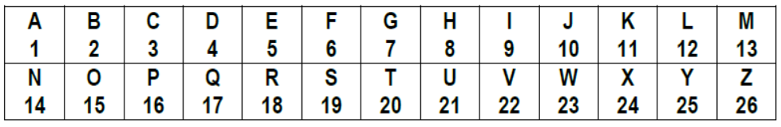
Draw below here

