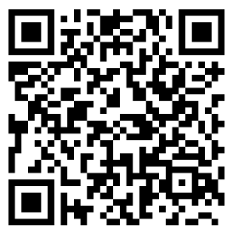
LESSON 1 unscramble sentences
NAME ___________________________
Directions: Retype or rewrite the sentence listed in the top row in the row just below each sentence to make it correct. Scan in the QR Code to check your answers.

- is full. Belly My
1.

- at good is English. He
2.

- a car. in I was
3

- I after ran ball. the
4.

- shine The at night. stars
5.

- Betty roses. likes
6.

- The is sleeping. lion
7.

- lay can A duck eggs.
8.

- eats after cake dinner. Tina
9.

- a bag. He has yellow
10.

