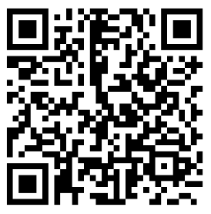
LESSON 2 unscramble sentences
NAME ___________________________
Directions: Retype or rewrite the sentence listed in the top row in the row just below each sentence to make it correct. Scan in the QR Code to check your answers.

- It was tall a tree.
1.

- apples. I some have
2.

- a have question. I got
3.

- bath. A is Kim taking
4.

- red a has He pencil.
5.

- dogs. Hot like I
6.

- red We that car. like
7.

- jump like to I rope.
8.

- sweet. Ruth is
9.

- high. Is bird flying The
10.

