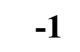 | 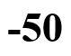 | 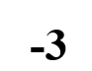 | 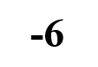
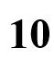 | 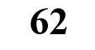 |  | 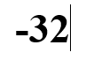
X + 2 = 8
X - 10 = 52
X + 9 = 8
X + 11 = 8
X - 2 = 8
X - 22 = 8
X + 40 = 8
X + 10 = -40

Lesson 1 NUMBERS

Name:
Directions:
- Move the number of each Algebra equation in the correct spot
- When completed Type your name in the space provided and printout your lesson and submit for a letter grade.

