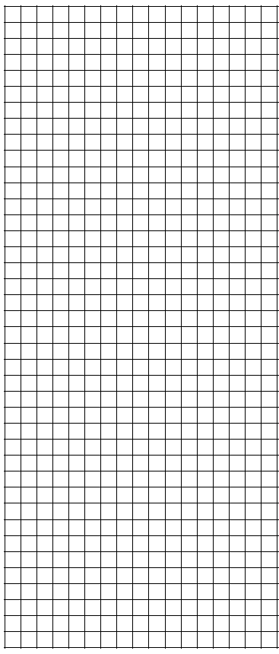
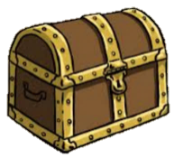
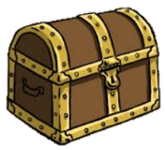
N

E

W

S

Name ______________
Lesson Math & Map
Directions: Find the Treasure Chest. Start from the circle in the middle and follow your way around the map using the clues you will obtain from the equations. Scan the QR Code to check your answers

- GO  - GO  - GO  - GO  - GO  - GO  - GO | 8.)GO  9.)GO  10)GO  11)GO

EXAMPLE GO EAST 8 + ___ = 12 GO NORTH 5 X ____ = 40

