
LESSON ? PICTURE MATH NAME ________________________________
UPPER LEVEL THINKING!
Directions: You must pay close attention to details. This lesson will provide you that opportunity. Figure out the value at the end of both problems. In the space provided place the value. You may click on the video to provide you with the answers
Problem A
Problem B
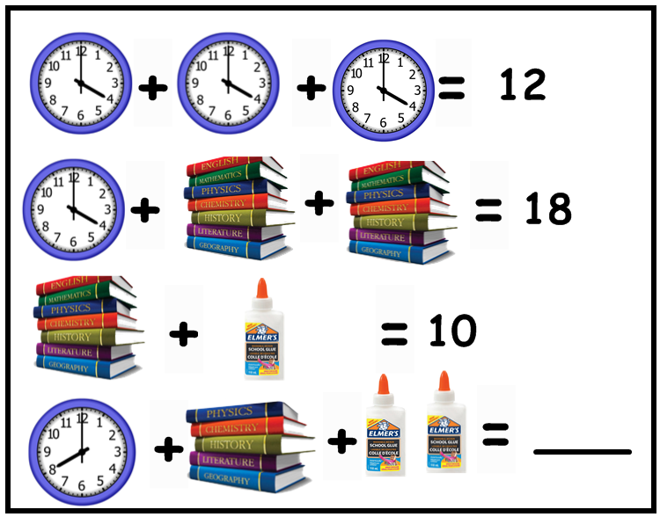
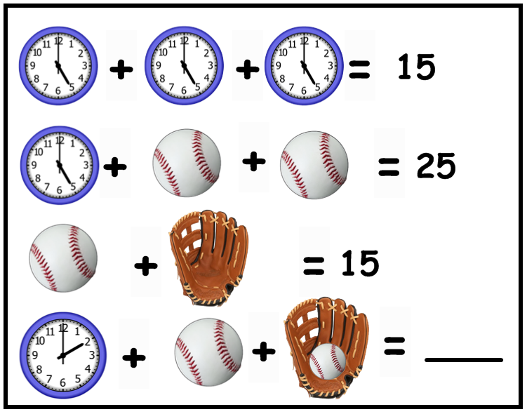

Working area

