Name ________________________ The SUBTRACTION using Codes
Directions: Crack the Code message listed below to uncover the numbers used for Subtraction. Place the answers in the space provided.
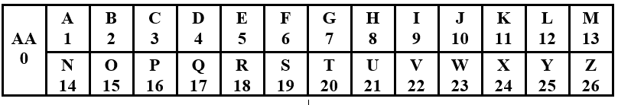
- E - C = B ANSWER __5__-__3____=__2__ Example
- F – B = D ANSWER _____-______=______
- H – C = E ANSWER _____-______=______
- J – D = F ANSWER _____-______=______
- G – C = D ANSWER _____-______=______
- I – F = C ANSWER _____-______=______
- L – H = D ANSWER _____-______=______
- J – G = C ANSWER _____-______=______
- O – J = E ANSWER _____-______=______
- K – I = B ANSWER _____-______=______

