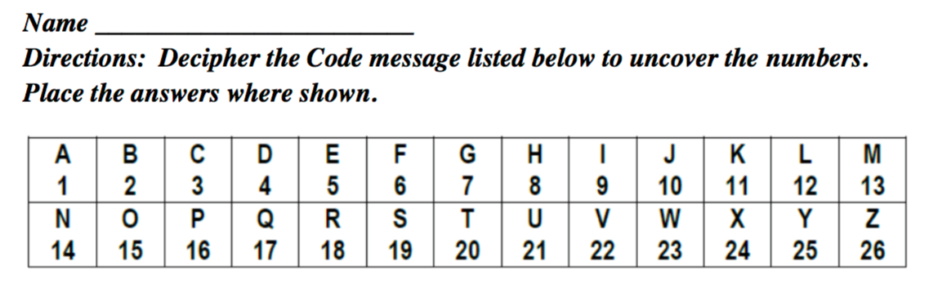
LESSON 5 Addition and Subtraction

- J + D = N ANSWER: 10 + 4 = 14 EXAMPLE
- O - C = L ANSWER: ___+___=___
- E - C = B ANSWER: ___+___=___
- O + E = T ANSWER: ___+___=___
- L - G = E ANSWER: ___+___=___
- C + G = J ANSWER: ___+___=___
- H + F = N ANSWER: ___+___=___
- M - G = F ANSWER: ___+___=___
- H + H = P ANSWER: ___+___=___
- I - E = D ANSWER: ___+___=___
Created by Autumn Zak

