Name ________________________ Division Lesson-1
Directions: Decipher the Code message listed below to uncover the numbers. Place the answers where shown. If the number requires a 0(zero) then use the AA to represent zero. Example: 60 = FAA 80 = HAA
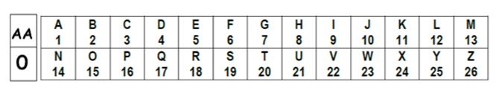
- Y / E = E 25 / 5 = __5____ EXAMPLE
- KAA / J = K ____ / _____ = ______
- R / B = I ____ / _____ = ______
- O / C = E ____ / _____ = ______
- R / F = C ____ / _____ = ______
- DI / J = J ____ / _____ = ______
- GAA / G = J ____ / _____ = ______
- GB / I = H ____ / _____ = ______
- ED / F = I ____ / _____ = ______
- DB / F = G ____ / _____ = ______

