Name ________________________
Directions: Decipher the Code message listed below to uncover the numbers. Place the answers where shown.
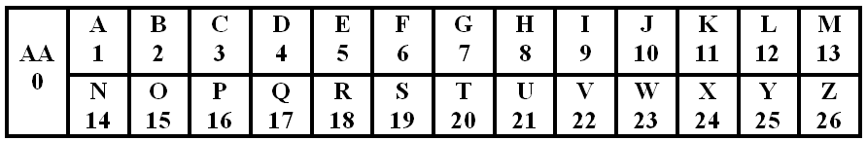
- L + H = T ANSWER: 12 + 8 = 20 EXAMPLE
- Z – Y = A ANSWER: ____ - ____ =

