 |  |  | 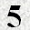
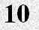 | 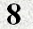 | 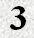
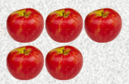

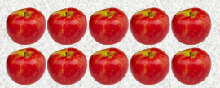

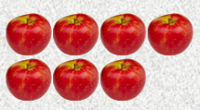
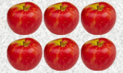
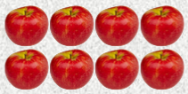
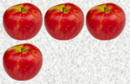
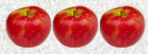

Lesson 1 NUMBERS

Name:
Directions:
- Move the number of each fraction in the correct spot for the fraction picture provided.
- When completed Type your name in the space provided and printout your lesson and submit for a letter grade.

