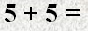 | 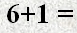 |  | Lesson 2 Subtraction  Name:  Directions: Move the equations to the correct Picture.
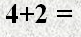 |  |  | 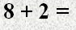
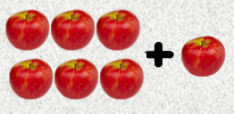 |  | 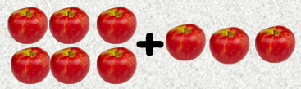
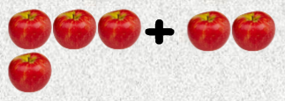 |  | 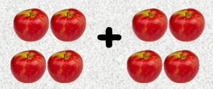
 |  | 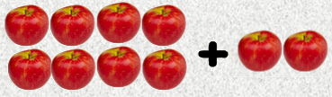
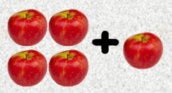 |  | 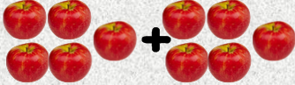
Answers
10 10 9 8 7 6 5 4

