Name
Thanksgiving - 3
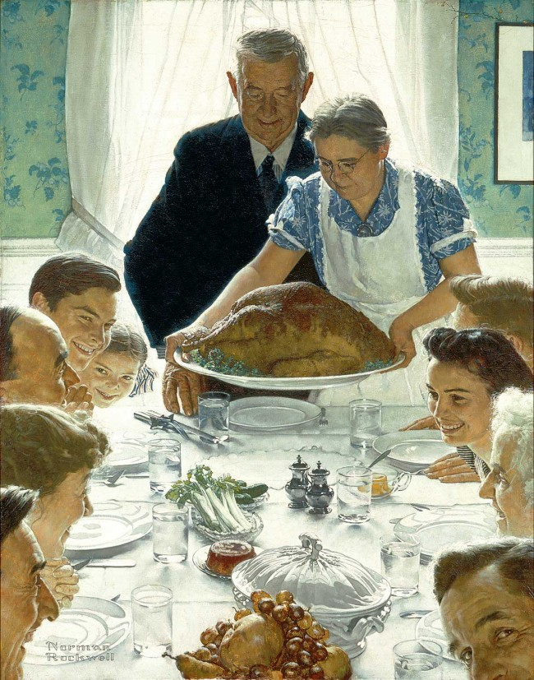

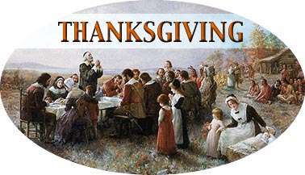

This is a picture of

This is picture of

Norman Rockwell “Freedom from Want”
This is a picture of

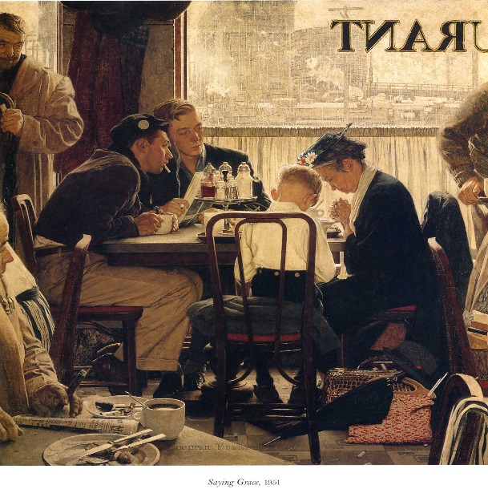
Norman Rockwell “Saying Grace”
This is a picture of

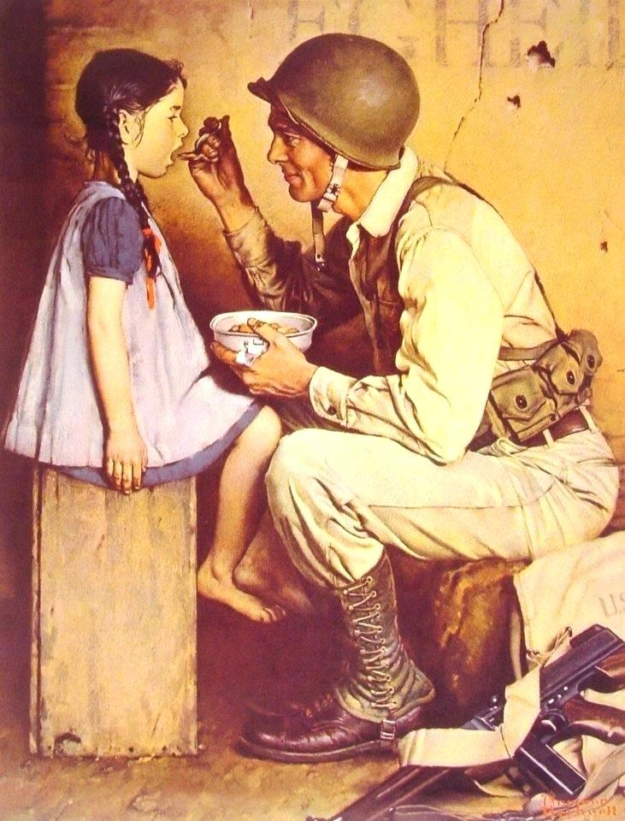
Norman Rockwell “Saying Grace”
This is a picture of

