Name
Veterans - 4
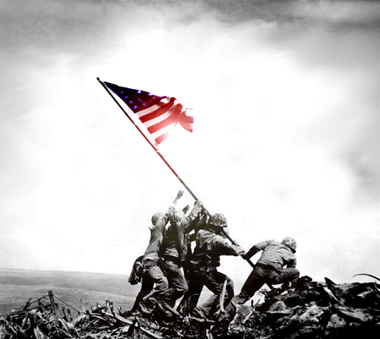
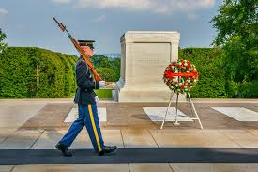

Tomb of the Unknown Soldier
This is a picture of

This is picture of

Battle of Iwo Jima
This is a picture of

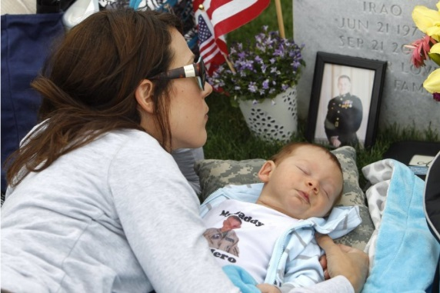
This is a picture of
This is a picture of

