Lesson 1 Name ________Microsoft Word
Directions: You will learn some basic but important directions using Microsoft Office. Microsoft Office is used everywhere so it is important to learn. Type your name at the top.
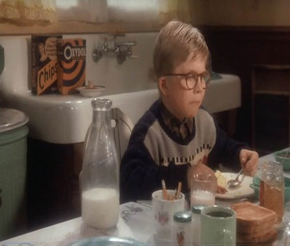
Inserting Photos in the table from Movie Christmas Story
- Adjust the lines of the table
  - Place cursor inside the empty table – Right click on mouse
  - Look for small box and borders & shading. Change width to #3 black
- Go to the website and find a picture you wish to place in the table from the movie.
- Pictures from: Christmas Story Movie
- Click on the photo and right click and copy image
  - Place photo in table cell and grab handle to reduce the size.
  - Click on picture and find TEXT WRAP (In front of Text)
- Highlight Penny and change it to Italic.
- Under the Home tab you will see Format Painter. Place the mouse on Penny and click on the Format Painter and change all of the wording to the same size and format as Penny.
- Click on the Find icon located to the far right then click on replace and type in Penny and change it to your name.
- Click on find again and change Kitten to Puppy.
- Find the word nice on the last line click on the word (nice) and find a pulldown menu and choose the word synonyms replace this word with enjoyable.
- Type your name at the top and printout or save a hardcopy depending where you attend school.
My name is Penny, and I am writing a brief story about Christmas day at our home. I got up early 6 am in the morning looking for gifts from Santa for myself and the rest of the family. Once we all opened up our gifts and exchanged cards and thank you notes for everyone. The gift of a kitten was really nice for the family. We named the kitten Sandy.

