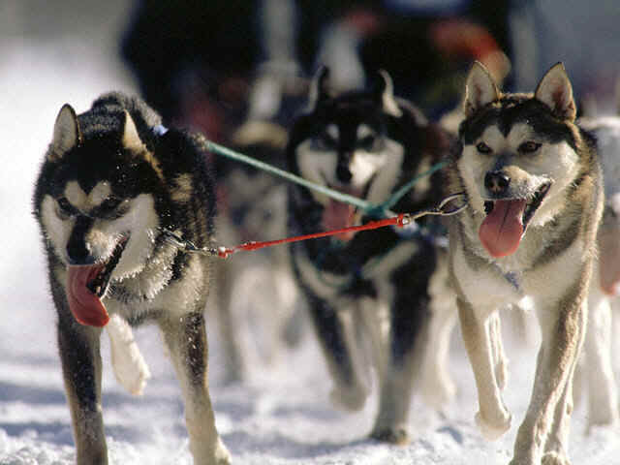
Iditarod Webquest:

Adapted by Tammi Lipovsky for 4th grade

Actual race
Begins on
The 1st
Saturday
In March

Task:
To convince your parents that Alaska is the best place to go for a vacation, your class is going to learn as much as they can about the race, Alaska, and the people that live there. To add to the fun, the class will act as a TV news team to gather information. There will be 5 types of reporters. Each one will cover one of the following topics: history, geography, art and culture, math, and science. We will have a live newscast that will be taped for parents to view.

History Reporters

What are you going to tell your parents when they ask about the Iditarod? Write down everything you learn about what it takes to be a successful musher. How do they prepare for a race?
Here are some key questions for you to search for to help you prepare for your history presentation.
- How many miles long is the Iditarod?
- What city does the Iditarod start in?
- What year did the Iditarod first run?
- Who is the "Father/Mother” of the Iditarod? Why is he/she called that?
- What does the word "Iditarod" mean? What language is it?
- What is the fewest number of dogs that a team can run with? What is the maximum number of dogs? (At the start and finish)
- What is the Red Lantern award? Why is it called that and to whom is it awarded?
- Who is Balto and where is he now?
- Who is Togo and where is he now?
- The official length of the race has significant meaning. What do the numbers refer to?
- What are the six items a musher must have with him/her at all times?
- How many mandatory stops must a musher take during the race?
- How long must a passed team wait before remain behind before demanding the trail?
- What happens if a big game animal is killed along the race route?
- What is the minimum age a musher must be in order to enter?
- How is the official finish determined?
- How can a musher be automatically disqualified?
- How does the musher control the direction of the dog team?
- What is the nickname that has been given to the Iditarod?
Geography Reporters
1. It will also be important for you to know about the area you will be visiting. Is it mountainous, flat,rough... You will design and create a map that marks the journey you will be taking following the Iditarod race. Be prepared to tell mom and dad the correct terms used for type of land you will be traveling through.
2. You might want to visit other areas of Alaska while there. Find some interesting sites such as national parks or landmarks your family might like to see.
Math Reporters
We know how much preparation goes into the race for these racers. There are so many details. We want to show your parents how much food it takes at each checkpoint to feed the dogs. You will need to write a short word problem on how to figure out how much food is required for the dogs at each point. Can you think of a creative way to demonstrate this during the presentation?

Science Reporters
The Aurora Borealis are a beautiful phenomena that are highly visible in the Alaskan night sky. Learn about the "Northern Lights" also known as the Aurora Borealis. What are the “Northern Lights”? What effects do these lights make on the race?
Art and Cultural Reporters
Your parents will surely want to see these beautiful lights and you can give them a taste by creating a painting of them using the "condensed milk paint" instructions.
Condensed Milk Paint
1 can condensed milk
food coloring

Pour small amounts of condensed milk into several small containers ( a 6 cup muffin tin works well). Add 2 or 3 drops of different colors of food coloring to each container and stir. Although this method is expensive, it makes vibrant, gorgeous colors and is well worth doing once a year.
Remember the learning never stops! We just rest in between the learning. 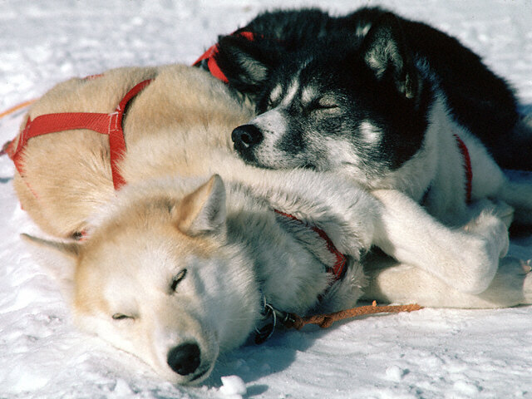
http://www.ultimateiditarod.com/faq.htm  Must read: questions and answers | http://www.adn.com/iditarod/  Anchorage Daily News
http://www.lincnet.org/hms/grade4/iditarod/iditarod.quest.html  Must read: webquest for 4th grade with questions to answer and great links | http://www.dogsled.com/  All the adventure - none of the frostbite! Great photos, a Kids Zone, weather and calendar of events.
http://education.nmsu.edu/webquest/wq/iditarod/ original newscast webquest  http://climate.gi.alaska.edu/Curtis/curtis.html northern lights | http://www.alaska.net/~design/scenes/iditarod/iditarod.html  A description of the first day of the race, and a short history. Great photos at the site from the 1996 race.  http://www.kidskonnect.com/Iditarod/IditarodHome.html  facts about the iditarod
http://www.sleddogcentral.com  Lots of links to sites with information about sled dogs and dog sled racing. | http://www.buserdog.com/buserdog  The web site of three time winner Martin Buser.
http://www.adn.com/iditarod/index.html Daily reports and news from the trail. Includes photos from the race, history and a Hall of Fame. | http://library.thinkquest.org/11313/Iditarod/index.html  Biographies of the four women who have won the Iditarod.
http://www.workingdogweb.com/Iditarod.htm  Links to the sleddog sport | http://teacher.scholastic.com/activities/iditarod/historic/index.asp?article=historic_iditarod
http://www.sleddog.com  A British site on sled dogs. | http://www.iditarod.com/information/info.htm  everything you need to know about an iditarod
http://www3.northstar.k12.ak.us/schools/awe/home/ernst/alaskanfacts.html  Alaska facts | http://mail.colonial.net/%7Eshoward/IditPhotos/IditPhotos.html  photos
http://aprn.org/iditarod/index.html  Alaska Public Radio Network | http://www.midgefrazel.net/wqiditarod.html  race cams
http://www.adn.com/iditarod/news/video/  ceremony start clips | http://www.ultimateiditarod.com/trailnotes.htm  checkpoints
http://baltosource.timduru.org/balto-act-b1mul-ong-1.html soundtrack of movie music | http://mikids.com/  iditarod links with game Want to be a millionaire?
http://www.iditarod.com/  official iditarod site | http://www.cabelasiditarod.com/index.html  official information
http://www.dogsled.com/kidszone/ | http://www2.lucidcafe.com/lucidcafe/library/iditarod.html  History of the Iditarod
http://www.mikids.com/Iditarodimages.htm  Iditarod pictures | http://webhome.crk.umn.edu/~dlim/Flash/iditarod.html  Who Wants to be a Millionaire? (Hopefully will return when the race begins.
Resources

Musher Bio-Poems
In this activity, you will create your own biographical poems about the musher you have chosen to follow in this year's race. You may find it beneficial to use the Official Iditarod website for musher information. There are some helpful musher biographical data there for you to read through.
First line | Write your musher's first name.
Second line | Write three (3) positive adjectives that describe your musher.
Third line | Write "Who likes..." and two to four things your musher might like.
Fourth line | Write "Who feels..." and a short phrase to finish the thought.
Fifth line | Write "Who needs..." and a short phrase to finish the thought.
Sixth line | Write "Who would like to see..." and a short phrase to finish the thought.
Seventh line | Write "Who enjoys..." and a short phrase to finish the thought.
Eighth line | Write "Who likes to wear..." and a short phrase to finish the thought.
Last line | Write your musher's first name again!
Iditarod Credits:
http://www.iditarod.com
http://education.nmsu.edu/webquest/wq/iditarod/
http://www2.grand-forks.k12.nd.us/Iditarod/iditarod.html

