
5th Grade Social Studies Web Quest:
The American Revolution
If you don’t know the meaning of a word, here are ways to increase your vocabulary:
- look it up in a dictionary
- www.wordcentral.com
A Web Quest is a fun way to walk through research. It’s like being a detective looking for the answers. Sometimes you have to use your prior knowledge (from class lectures and other reading like the textbook) along with new information to form an answer.

You’re encouraged to work with friends and discuss answers, though that’s not required. When you work in a team, be sure to give credit to the entire team.

Don’t wait until the last minute to do all of this. Do a little bit each day.
- www.dictionary.com
Worked with Team Members:
________________________
________________________

Instructions | What you should see after following the instructions.
Go to:  http://bensguide.gpo.gov | Ben’s Guide to U.S. Government for Kids  A picture of Benjamin Franklin Flying a Kite. Links in the kite for different grade levels.
Click on the link:  “6-8” | Grades 6 - 8  Benjamin Franklin pointing to a chalk board with links on it.
Click on the link:  “Historical Documents” | Historical Documents  Links to the most important documents in U.S. political history from 1776 to 1863.
Click on the link:  “Declaration of Independence” | The Declaration of Independence  Links to the most important documents in U.S. political history from 1776 to 1863.

Answer the following questions.
(Due to time limitations, complete sentences are not required.)
- What does the Declaration of Independence signify?
_____________________________________________________________________________
- Who penned (authored and wrote) the Declaration of Independence? (first and last name)
_____________________________________________________________________________
- We celebrate July 4th every year? Why? What happened on that day? _________________
_____________________________________________________________________________
- What had happened two days earlier on July 2nd? __________________________________
_____________________________________________________________________________
- Describe the main topic of the two sections of The Declaration of Independence.
Part 1: _____________________________________________________________________
___________________________________________________________________________
Part 2: _____________________________________________________________________
___________________________________________________________________________
- Define the following words that are in the Declaration of Independence.

self-evident ____________________________________________________
______________________________________________________________

endowed _______________________________________________________
______________________________________________________________

unalienable ____________________________________________________
______________________________________________________________

rights ________________________________________________________
______________________________________________________________

pursuit ________________________________________________________
___________________________________________________________
- In your own words, how would you describe to an 8-year old what this sentence means:
We hold these truths to be self-evident, that all men are created equal, that they are endowed by their Creator with certain unalienable Rights, that among these are Life, Liberty and the pursuit of Happiness.
______________________________________________________________________________
______________________________________________________________________________
______________________________________________________________________________
______________________________________________________________________________
- To secure the rights of Life, Liberty and the pursuit of Happiness, governments are created that get their power from whom?
______________________________________________________________________________
______________________________________________________________________________
______________________________________________________________________________
- When a government becomes destructive of Life, Liberty and the pursuit of Happiness, what do the people have the right to do?
______________________________________________________________________________
______________________________________________________________________________
______________________________________________________________________________
- The Declaration of Independence points out that history has shown that mankind has a tendency to endure suffering at the hands of evil doers rather than do the work and take the risks needed to make things right. What does it say is a person’s duty (obligation) when faced with ongoing abuse?
______________________________________________________________________________
______________________________________________________________________________
______________________________________________________________________________

Instructions | What you should see after following the instructions.
Go to:  www.s9.com/biography/search.html | The Biographical Dictionary – Search Page
Enter the name of the person you want to research and then click the “Begin Search” button. | Information about the person you are researching.
When finished, click the “Back” button in your web browser to conduct another search. | The Biographical Dictionary – Search Page
Answer the following questions.
(Due to time limitations, complete sentences are not required.)

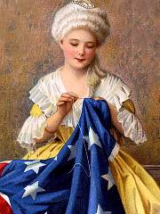
- Betsy Ross was born in 1752 and sewed the 1st American Flag in 1776. How old was she when she sewed the flag?_______________________
- What year did the Continental Congress adopt as our nation’s flag the design that Betsy Ross had sewn? ______________________________
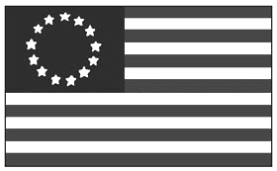
How many stars are on the original U.S. flag? _____________________________________
- How many stripes are on the original U.S. flag? ___________
- Why that number? __________________________________
- How many stars are on the U.S. flag today? _______________________
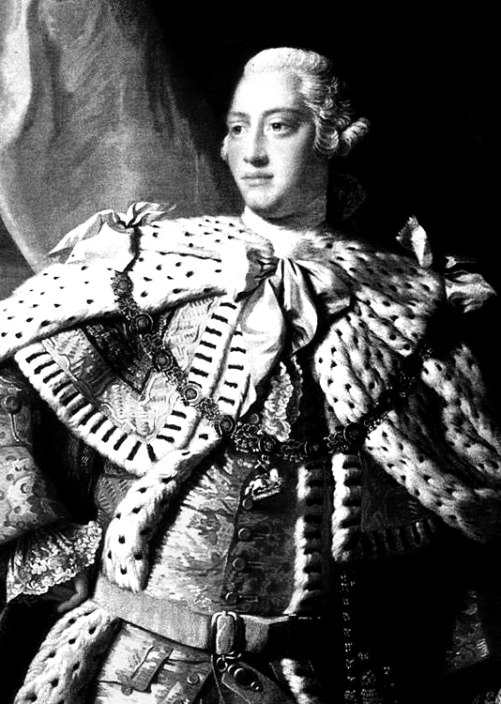
- Why that number? ___________________________________________
- Who was George III? ________________________________________
_____________________________________________________________
- What was his lifespan (that is, the years he was born and died)?
_____________________________________________________________
- Who was Patrick Henry? _________________________
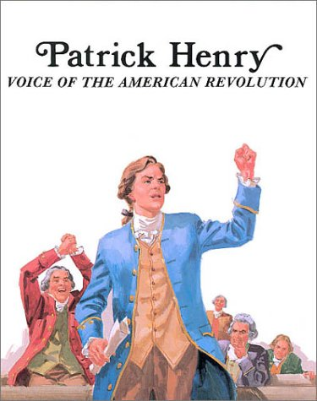
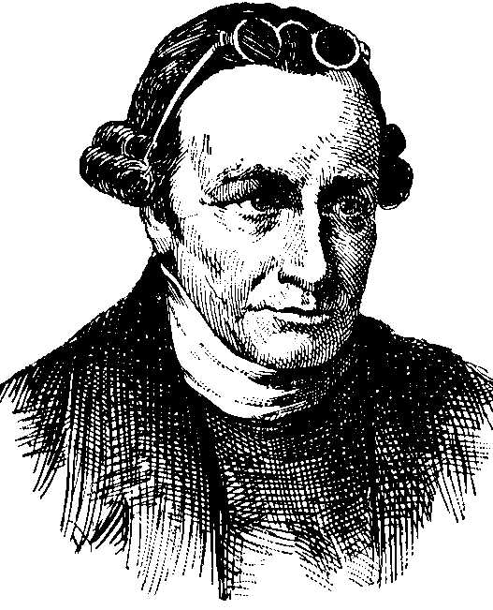
_________________________________________________
Patrick Henry
_________________________________________________
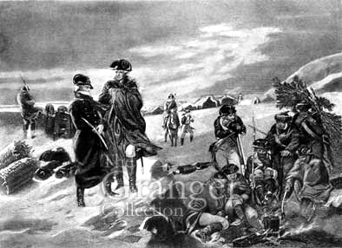
____________________________________
George Washington at Valley Forge

- What was George Washington’s military title during the Revolutionary war?
______________________________________________________________________________

- Who was Benedict Arnold? ____________________________________________________
______________________________________________________________________________
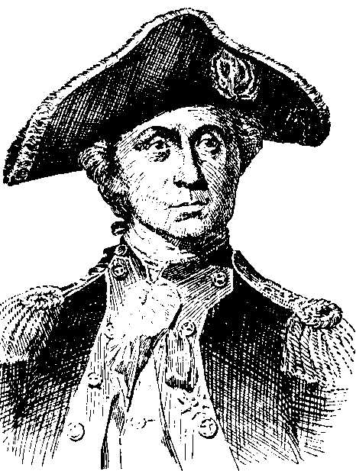
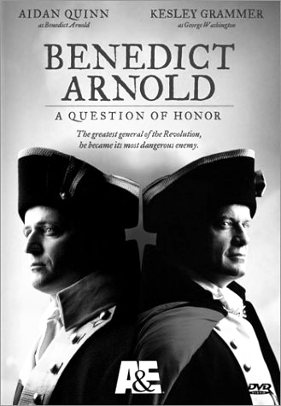
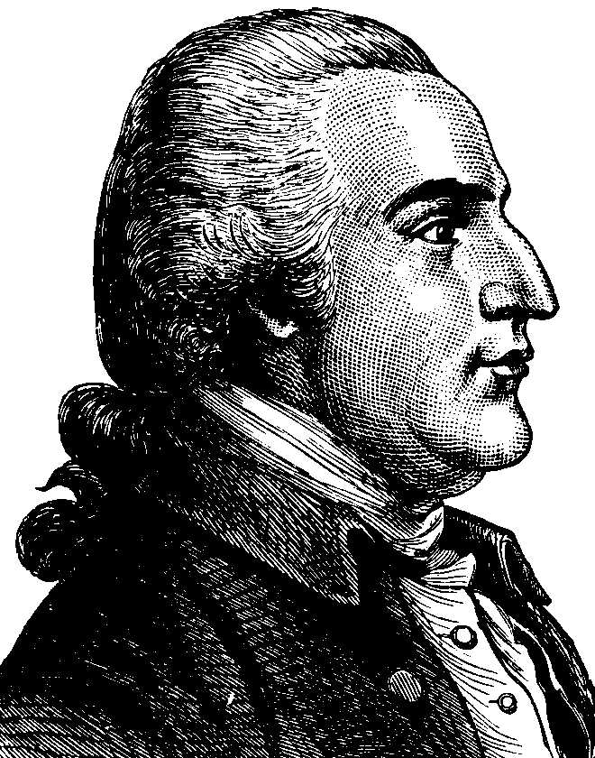
- Who was John Paul Jones? (see http://navysite.de/dd/ddg53.htm )
John Paul Jones
Benedict Arnold
_________________________________
_________________________________
_________________________________
_____________________________________________________
- Who was Sam Adams? _______________________________
__________________________________________________
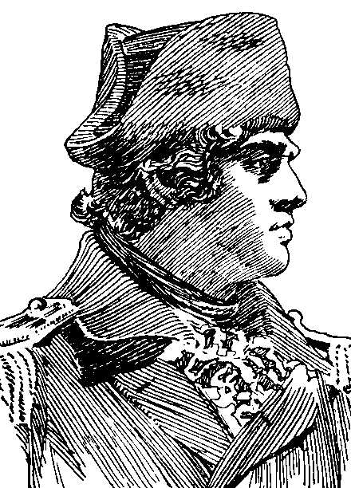
- Who was Ethan Allen? ______________________________________
Ethan Allen
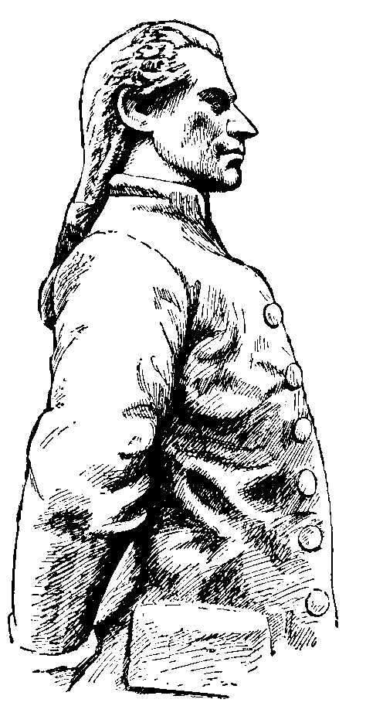
____________________________________________________________
Nathan Hale
- Who was Nathan Hale? ______________
_____________________________________________________
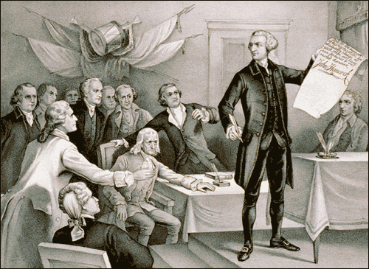
_____________________________________________________
John Hancock
- Who was John Hancock?
__________________________
__________________________________________________
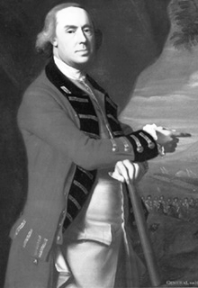
______________________________________________________________________________
- Who was General Thomas Gage?
(http://www.u-s-history.com/pages/h1292.html)
______________________________________________________
______________________________________________________
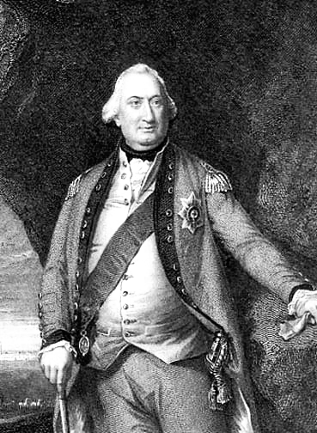
______________________________________________________
Cornwallis
General Thomas Gage
- Who was Cornwallis? _______________________________
____________________________________________________
___________________________________________________
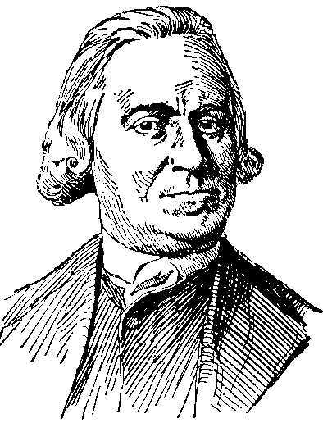
- Who was Sam Adams? _______________________________________
Sam Adams
_____________________________________________________________
- Who was Marquis de Lafayette? (see http://www.ushistory.org/valleyforge/served/lafayette.html)
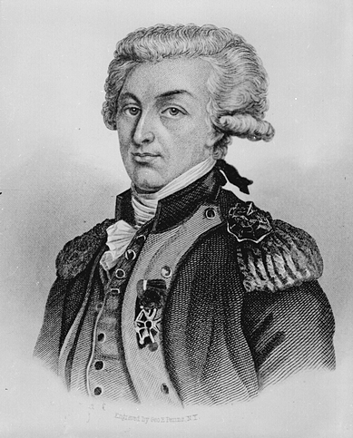
_______________________________________
Lafayette
______________________________________________________
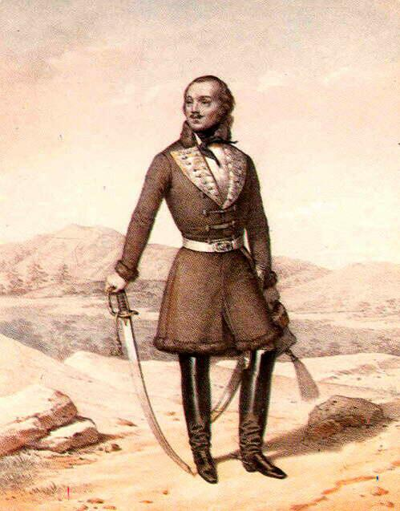
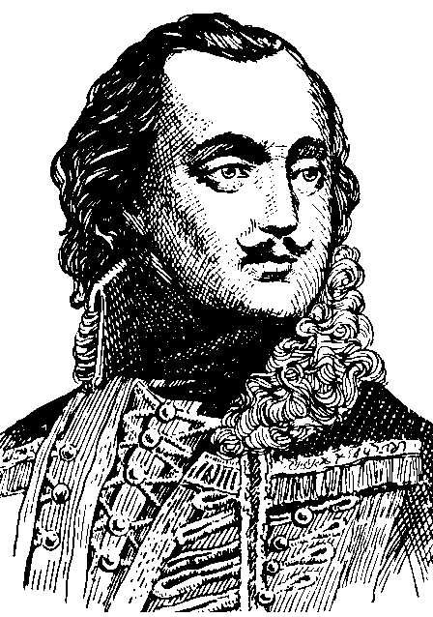
______________________________________________________
General Pulaski
- Who was General Pulaski?
_________________________
__________________________________________________
_______________________________________________________
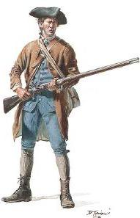
- Who were the minutemen? __________________
Minuteman
___________________________________________
___________________________________________
- What is a militia? ________________________________________________
____________________________________________________________
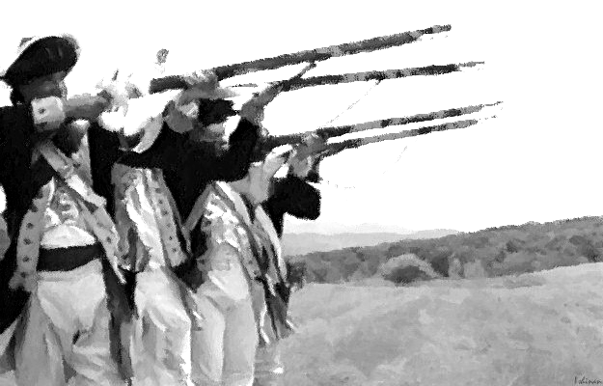
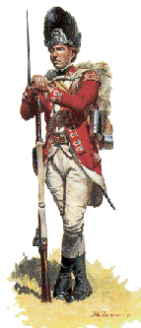
- Who were the redcoats? _______________________
militia
redcoat
_______________________________________________
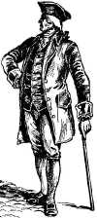
- Who were the loyalists?
loyalist
_____________________________________________________________
____________________________________________________________

Instructions | What you should see after following the instructions.
Go to:  www.pbs.org/wgbh/aia/part2/map2.html | The Biographical Dictionary – Search Page
Enter the name of the person you want to research and then click the “Begin Search” button. | Information about the person you are researching.
When finished, click the “Back” button in your web browser to conduct another search. | The Biographical Dictionary – Search Page

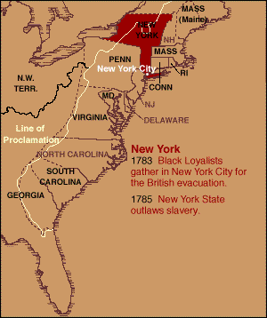
Write the names of the colonies in order from North to South:

1. ____________________________________

2. ____________________________________

3. ____________________________________

4. ____________________________________

5. ____________________________________

6. ____________________________________

7. ____________________________________

8. ____________________________________

9. __________________________________________________________________________

10. _________________________________________________________________________

11. _________________________________________________________________________

12. _________________________________________________________________________

13. _________________________________________________________________________
Instructions | What you should see after following the instructions.
Go to:  www.multied.com/revolt/Battles.html | Major Events of the Revolutionary War  Links to information about important events.
Click on the link for the event you want to research.  Click the link for “More Information” to find detailed answers. | Information about the event.
When finished, click the “Back” button in your web browser to conduct another search. | Major Events of the Revolutionary War  Links to information about important events.
Fill in the following tables like this one.
Event #1 | Location | Description
Battle of Lexington & Concord | Lexington & Concord, Massachusetts | The battle started in Lexington where the British killed 17 colonists. Then, they marched toward Concord. When the British set fire to some supplies in Concord, the colonists went to defend the town, but the British held onto Concord. By noon, the British commander Colonel Smith decided that he could withdraw to Boston. As he withdrew, militia began surrounding his troops on all sides. The American militiamen seemed to be everywhere on the road between Concord and Lexington firing at the retreating British troops. Just beyond Lexington the British forces were joined by a force of 1000 soldiers led by Lord Percy. The British once again advanced on Lexington, capturing the southern part, and plundering homes there, until the mass of gathering militia became too great. They withdrew to Boston. During the day, 1,800 British soldiers had met approximately 4,000 Americans. The British lost 65 soldiers with an additional 173 wounded. The Americans lost 49 militia members and had 46 wounded. The war was on – there was no turning back!
Date | Victors
April 19, 1775 | Rebel Militia
What was significant about this event? |  |  | This battle began the Revolutionary War that eventually lead to independence from the King of England (Great Britain).

Event #2 | Location | Description
The Battle of Bunker Hill
Date | Victors
What was significant about this event?

Event #3 | Location | Description
Attack on Canada
Date | Victors
What was significant about this event?

Event #4 | Description
U.S. Navy Created
Date
What was significant about this event?

Event #5 | Description
Common Sense Published
Date
What was significant about this event?

Event #6 | Location | Description
Battle of Trenton
Date | Victors
What was significant about this event?

Event #7 | Location | Description
Battle of Germantown
Date | Victors
What was significant about this event?

Event #8 | Location | Description
Battle of Saratoga
Date | Victors
What was significant about this event?

Event #9 | Location | Description
Valley Forge
Date | Victors
What was significant about this event?

Event #10 | Location | Description
Treaty of Amity with France
Date | Victors
What was significant about this event?

Event #11 | Location | Description
John Paul Jones and Bonne Homme Richard
Date | Victors
What was significant about this event?
Event #12 | Location | Description
Arnold a Traitor
Date | Victors
What was significant about this event?

Event #13 | Location | Description
Battle of Cowpens
Date | Victors
What was significant about this event?
Event #14 | Location | Description
Bottle of Yorktown
Date | Victors
What was significant about this event?

Event #15 | Location | Description
Treaty of Paris
Date | Victors
What was significant about this event?

_____________________________________________________________________________________________________________

_____________________________________________________________________________________________________________

_____________________________________________________________________________________________________________

_____________________________________________________________________________________________________________

_____________________________________________________________________________________________________________

_____________________________________________________________________________________________________________

_____________________________________________________________________________________________________________

_____________________________________________________________________________________________________________

_____________________________________________________________________________________________________________

_____________________________________________________________________________________________________________

