
Miss Rumphius WebQuest
A 3rd Grade WebQuest Based on the book “Miss Rumphius” by Barbara Cooney
Jennifer Gross – 4 June 2008
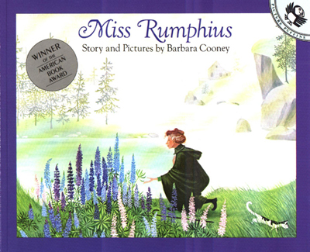

Welcome to the Miss Rumphius WebQuest!

Introduction
Miss Rumphius did many wonderful things in her lifetime, but one of the best things that she did was plant beautiful lupine flowers all over the countryside for other people to see and enjoy.
Now it’s YOUR turn to share some beauty with the rest of your school. This WebQuest is a challenge to you to research, plan, and grow your very own class flower! Follow the tasks and have fun!


Task
Here is what you will be doing:

 Listening to the story of Miss Rumphius and filling out a 3-2-1 chart about the story.
 Choosing a flower to research using the tools and resources in this WebQuest
 Creating a poster on the computer about your flower using Kidpix and Word which will include an original picture that you draw and some interesting facts
 Voting on a class flower using MicroPoll online and planting the flower in the school garden!

Process #1 - Find a good piece of Earth

The first step in this WebQuest is to listen carefully as your teacher reads you the story “Miss Rumphius” by Barbara Cooney. Once the story is finished you will receive a 3-2-1 Chart that you will complete on your own. A 3-2-1 chart is divided into 3 parts:

3) Write three things you found out
2) Write two things that are interesting to you about the story
1) Write one question that you still have

This is what the sheet will look like:
3
THINGS YOU FOUND OUT:
2
INTERESTING THINGS
1
QUESTION YOU STILL HAVE
ReadingQuest: Making Sense in Social Studies From an idea shared by Penny Juggins
http://www.readingquest.org Fairfax County, Virginia

When everyone is finished filling out their 3-2-1 chart you will have a chance to share, out loud, something you found out, something interesting to you, and one question you have.



Process #2 – Choose a Flower to Grow

The second step in this WebQuest is choose one of the following flowers that you would like to research using the resources and web links listed below. You do not have to have a flower in mind before beginning; you may browse before you find one that you like. When you find one, tell your teacher and he or she will write it down. Also, you may find it helpful to take notes on another piece of paper. Remember that you will need 3 facts for your poster and a good idea of what your flower looks like! Ask your teacher for help if you need it.

Flowers to Choose From:
 Rose
 Daisy
 Marigold
 Daffodil
 Hyacinth

General Resources:

Books
“Flowers” by David Burnie, call # 582.13 Bu
“Flowers” by Paul McEvoy, call # 582.13 Mce
“A Child’s Book of Wildflowers” by M.A. Kelly, call # 582.13 Ke
“How Flowers Grow” by Emma Helbrough, call# 575.6 He
“Draw 50 flowers, plants and trees” by Lee J. Ames, call# 743.7 Am

Movies
“Bill Nye the Science Guy – Flowers”, call # 635.9 Bi
“All about plants, pollination, fruit, flowers, and seeds”, call # 571.8642 All

Databases
Encyclopedia Smithsonian
http://www.si.edu/Encyclopedia_SI/default.htm

Fact Monster
http://www.factmonster.com/

Gardening for Kids
http://www.geocities.com/EnchantedForest/Glade/3313/

Plants and Our Environment
http://library.thinkquest.org/3715/

Rose Resources:
The American Rose Society Online
http://www.ars.org/

Gardening Guru – Rose Garden Information
http://www.rosegardeningguru.com/

Rose Photographs
http://www.justourpictures.com/

Daisy Resources:
The Gardener’s Network – Daisies
http://www.gardenersnet.com/flower/daisy.htm

USDA Plant Profile – Daisy
http://plants.usda.gov/java/profile?symbol=BEPE2

Garden Guides – Daisy
http://www.gardenguides.com/plants/find-plant.asp?q=Daisy+flower

Marigold Resources:
Garden Guides – Marigolds
http://www.gardenguides.com/plants/info/flowers/annuals/marigold.asp
West Virginia University – Marigolds
http://www.wvu.edu/~Agexten/hortcult/flowers/marigold.htm

Marigold – Clemson University
http://hgic.clemson.edu/factsheets/hgic1168.htm

Daffodil Resources:
American Daffodil Society
http://www.daffodilusa.org/

DaffyBill’s Daffodils
http://homepage.mac.com/daffybill/daffodils/

Garden Guides – Daffodils
http://www.gardenguides.com/plants/info/flowers/bulbs/daffodil.asp

Hyacinth:
Garden Guides – Hyacinths
http://www.gardenguides.com/plants/info/flowers/bulbs/hyacinth.asp

The Flower Expert – Hyacinth
http://www.theflowerexpert.com/content/growingflowers/growingflowers/hyacinth

The Gardener’s Network – Hyacinth
http://www.gardenersnet.com/flower/hyacinth.htm

Process #3 – Plant and Water the Seed

The third step in this WebQuest is the most creative of all of the steps! You will be making a poster about the flower that you researched which will include a picture that you draw on KidPix or Paint and 3 facts about that flower that you will type up on Word and print off.

First, open up the KidPix or Paint program using the icons on the desktop. Use the computer painting tools to create a picture of your flower. Here is an example of a drawing of a tulip using Paint.

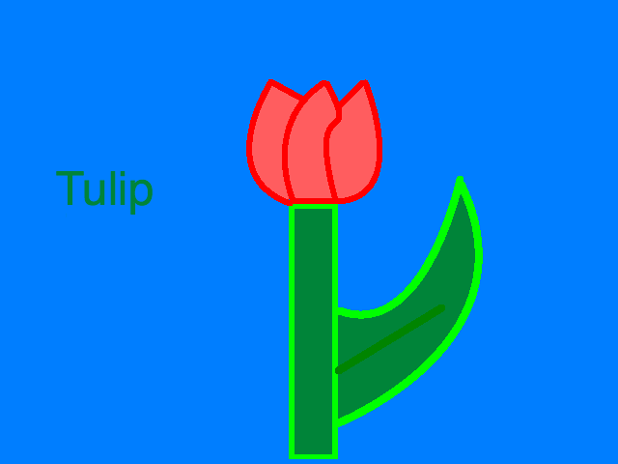

Once you have finished creating the drawing of your flower, tell your teacher and he or she will print it off on the color printer. As soon as your picture prints WRITE YOUR NAME ON THE BACK!!! This way the pictures won’t get mixed up.
Next, open up the Word program using the icon on the desktop and follow these directions for writing your flower facts:

- Write your name at the top of the page in size 24 font, Times New Roman.
- Write the name of your flower under your name in the same font
- Hit enter 3 times and type your first flower fact
- Hit enter again and type your second flower fact
- Hit enter again and type your third flower fact
- Check for any spelling or grammar errors using spell check
- Raise your hand when you are finished and your teacher will print off your flower facts

Once you are done printing off your drawing and flower facts you are ready to make your poster! Get a piece of poster board and a glue stick and arrange the parts of your poster like this:

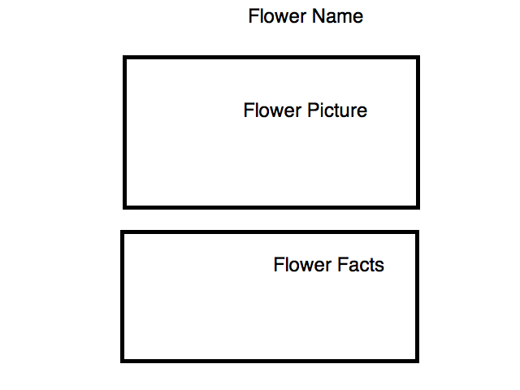

When you are done making your poster, turn it in to your teacher and he or she will put it in the “Flower Garden” display in the hallway for everyone to see and enjoy!

Process #4–Watch a Beautiful Flower Grow

In order to vote on which flower the class will choose, we will be using an interactive website called MicroPoll. MicroPoll allows you to create your own poll which can be used for voting on the topic of your choice. The poll that we will be using to vote with has already been created, and all you have to do is log onto the site and cast your ballot!

Remember, voting is private and nobody else needs to know what you voted for. Also, you are NOT allowed to vote for your own flower. Take a look at the bulletin board with all of the flower pictures and facts and decide which one you think would be the best addition to the class garden. Here is how you will vote:

Click on this link which will take you to our class poll:
http://www.micropoll.com/akira/mpview/437700-94993
Vote for your favorite by clicking on the bubble to the left of the name of the flower you want to select. Click on the orange “Vote” button. See the screen shot for details:

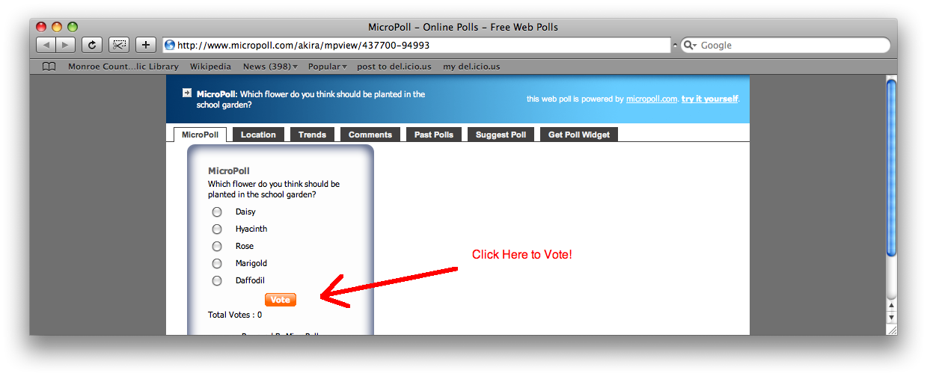
When you are done voting, another page will open up with the results of the class poll. Your teacher will print off the final chart and announce which flower is the winner.


Process
The Process step in this WebQuest lets you get your hands dirty! Once everyone has voted and a flower has been chosen, your class will have an opportunity to share this beautiful flower with the rest of the school just like Miss Rumphius. Your teacher will bring in seeds or bulbs to plant in the school garden. Each of you will get to plant one seed or bulb and watch it as it grows over the next couple of months!
Because flowers can only grow during certain parts of the year, but they are nice to enjoy all year round, your class will also be taking pictures of your flowers as they grow so that you can enjoy them, even in the winter! Also, all of the pictures will be used in a special laminated book that will be on display in the library with your flower posters so that years from now students at your school can look at the beautiful flowers that you planted and enjoy them all over again!

Evaluation
This project is graded on a number of different things. Participation, willingness to explore new technology, and effort are all important aspects of this WebQuest. Below you will find a checklist that you can use to make sure that you remember to complete every last detail of the assignment. You will also find a grading rubric for the project.

Checklist
Check Off Box | Task
 | 3-2-1 Chart Completed
 | Choose a flower to study
 | Research using Resources
 | Flower drawing with Paint or KidPix
 | 3 flower facts using Word
 | Flower Poster
 | Voted Online using MicroPoll

Grading Rubric

Task | Grade/10
Listened attentively and respectfully to the story | /10
Completed the 3-2-1 chart | /10
Participated in 3-2-1 chart discussion | /10
Used resources to research flowers online | /10
Used library and computer technology correctly | /10
Created a flower picture using KidPix or Paint | /10
Typed up 3 interesting flower facts using Word | /10
Created a neat and interesting poster | /10
Voted online for favorite flower on MicroPoll | /10
Participated in the flower planting in the garden | /5
Overall Positive Mental Attitude | /5
Total Grade | /100


Conclusion
Congratulations! Miss Rumphius would be proud of everything that you have done to make your school and your world a better place! In the springtime when the flowers that you and your class have planted are in full bloom there will be a special picnic lunch and you will get to eat outside among the beautiful flowers that you have planted! Have fun!

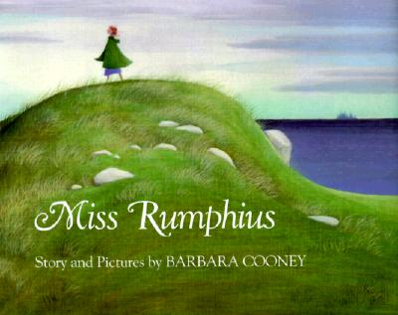

Teacher Page

The story of Miss Rumphius is an old and popular one which focuses on the character development of a young girl named Alice who grows up to be the Lupine Lady. This WebQuest gives students the opportunity to both research a certain topic using appropriate resources, as well as have fun using interactive multi-media software and websites. It is also an opportunity for community building in your school as children will be encouraged to consider the implications of sharing something beautiful with others.
This WebQuest is intended for 3rd graders, but it can easily be modified for 2nd or 4th graders by either including more challenging material or offering help with certain resources that may be harder for young children to navigate.
While this WebQuest may be a great deal of fun, it is also a useful learning tool across the curriculum. Students will be studying gardening, horticulture, plant growth, technology, grammar, art, and will be developing their writing and computing skills. The 3rd grade English and Language Arts standards that are highlighted upon in this WebQuest are listed below.

Grade 3 English/Language Arts Standards:
3.1.5 Demonstrate knowledge of grade-level-appropriate words to speak speciﬁcally about different issues.

3.2.6 Locate appropriate and signiﬁcant information from the text, including problems and solutions.

3.2.7 Follow simple multiple-step written instructions.

3.4.4 Use various reference materials (such as a dictionary, thesaurus, atlas, encyclopedia, and online resources).

3.4.5 Use a computer to draft, revise, and publish writing.

3.4.6 Review, evaluate, and revise writing for meaning and clarity.

Related Lesson Plans
(not all of the lesson plans linked here are available for free, but many are inexpensive and come with free downloads)

Flowers: A Thematic Cross-Curricular Unit
http://store.atozteacherstuff.com/download-now/abc_flowers.html

Color Garden
http://www.eduplace.com/rdg/gen_act/color/garden.html

Plants – A Thematic Unit
http://pan.tcnj.edu/plant.htm

Friendly Flowers Lesson Plan
http://www.learningtogive.org/lessons/unit74/lesson2.html

Timeline
Depending on the abilities of your students and the amount of time available to you, this WebQuest can be completed in one day, one week, or one month. Below is one way in which you can divide up this WebQuest into “petals”. When all of the petals are combined they make a flower and that is your planting day when you do all of the gardening outside.

Petal #1 – Read aloud Miss Rumphius, complete the 3-2-1 chart, and facilitate a class discussion on the chart findings

Petal #2 – Computer Lab/Library Day, choose a flower and research it using the WebQuest resources

Petal #3 – Computer Lab Day, create flower drawing and flower facts on the computer.

Petal #4 – Art Day, Make flower posters

Petal #5 – Computer Lab Day, vote on favorite flower

Other books by Barbara Cooney:

Island Boy
http://www.amazon.com/Island-Picture-Puffins-Barbara-Cooney/dp/0140507566/ref=pd_bbs_sr_3?ie=UTF8&s=books&qid=1213291962&sr=8-3

Hattie and the Wild Waves
http://www.amazon.com/Hattie-Wild-Waves-Brooklyn-Picture/dp/0140541934/ref=pd_bbs_4?ie=UTF8&s=books&qid=1213291994&sr=8-4

Eleanor
http://www.amazon.com/Eleanor-Barbara-Cooney/dp/0670861596/ref=pd_bbs_7?ie=UTF8&s=books&qid=1213292047&sr=8-7

Emma
http://www.amazon.com/Emma-Picture-Yearling-Barbara-Cooney/dp/0440408474/ref=pd_bbs_5?ie=UTF8&s=books&qid=1213292075&sr=8-5


Credits
This WebQuest was based on the book Miss Rumphius, written and illustrated by Barbara Cooney. All of the images are from the book as well.
This WebQuest was also developed with inspiration from Susan Eley’s WebQuest Blueberries! NJ’s State Fruit. https://oncourse.iu.edu/portal/site/SU08-IN-SLIS-S603-7739/page/87e1eae2-7062-4376-00eb-fff1c9dfcf6f

