My 1st time at Museum

I have written a story about my 1st time at
Natural History Museum. Here is my example. Now use your imagination and write your own.

My Story:

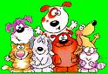

On my first day at museum, I was scared because I thought the animals are real. The way that animal were looking at me seemed like they want to jump on me and eat me. Especially I saw the night at the museum movie last month and I thought they would become a live at night. I wanted to go home before it gets dark. But also I learned a lot of things about the nature.
Your Story:

