Finding the Meanings of Words
I pledge allegiance to the flag of the United States of America, and to the republic for which it stands, one nation under God, indivisible, with liberty and justice for all.
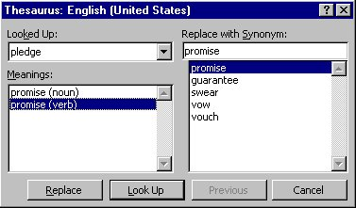
Word does not come with a built in dictionary, but it does have a thesaurus. By double clicking on a word to select it, then looking it up in the thesaurus, students are able to get a variety of other words that give them a connotative definition of unfamiliar words. This usage provides great practice for future writing skills. Because this type of file is so basic in that it only contains some font color changes, we did not include a downloadable Word file. The example above uses the Pledge of Allegiance and shows a screen shot of the options available through the thesaurus. One word of caution: it is best to use root words that are in the present tense.
Instructions:
- Double click on the first colored word to select it.
- Go to Tools > Language > Thesaurus > and click.
- Read the various meanings for the word.
- Which do you think fits the best? Why?
- How would you define the word?
- Can you rewrite the sentence(s) using your own words?
- Repeat these instructions for each of the colored words.

