Examine each country outline. Write the correct name of each South American country in the space next to the corresponding outline. If you need help, highlight the “hint” box and clues about the country will appear to guide you. Good Luck!

COUNTRY OUTLINE | NAME OF COUNTRY | HINT
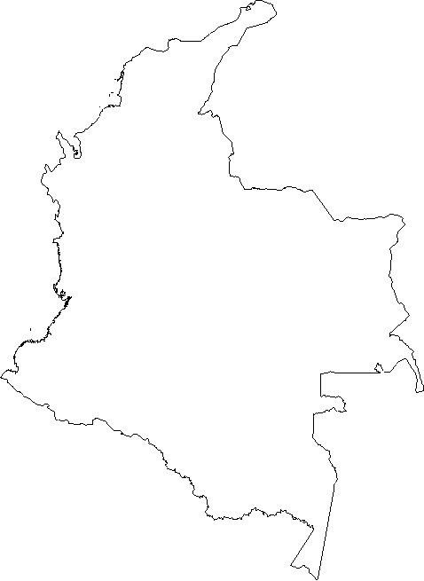 |  | This country is located in the north.  The capital is Bogota
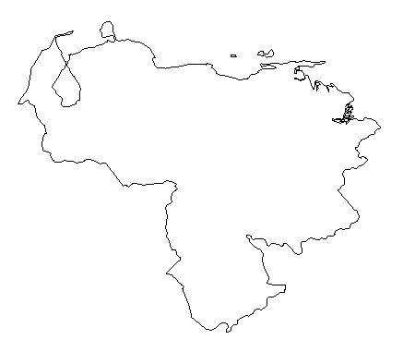 |  | This country is located in the north.  The capital is Caracas
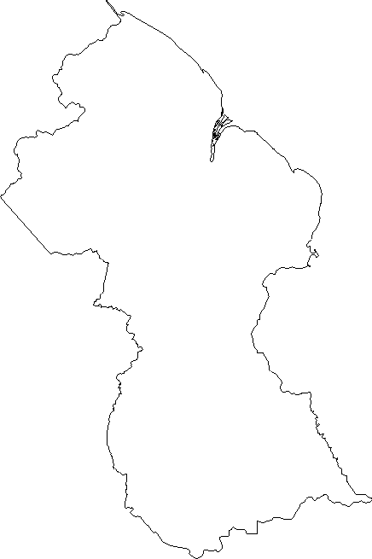 |  | This country is located in the north.  The capital is Georgetown
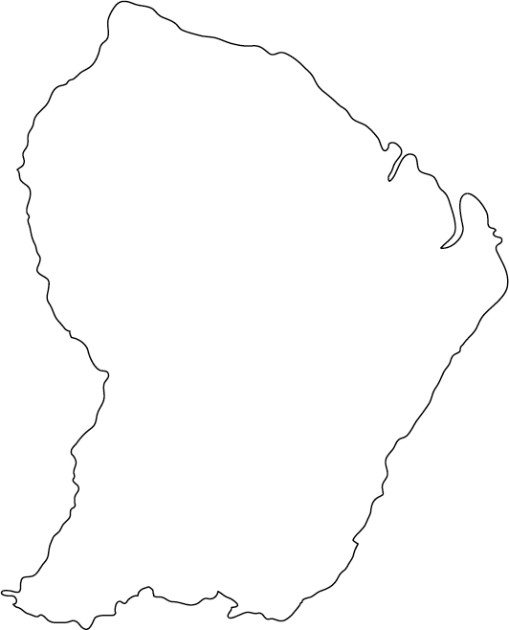 |  | This country is located in the north.  The capital is Cayenne
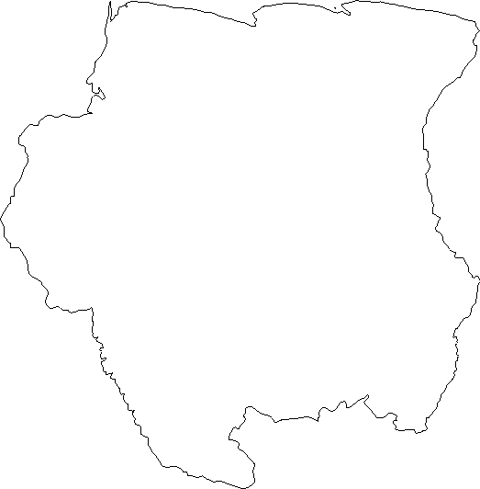 |  | This country is located in the north.  The capital is Paramaribo
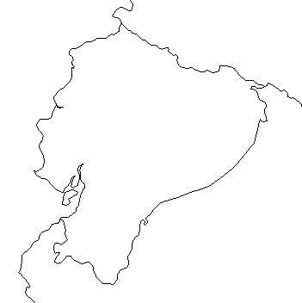 |  | This country is located on the Equator.  The capital is Quito
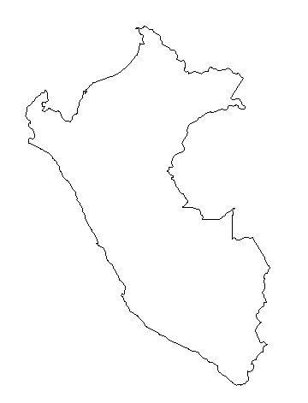 |  | This country is on the north west coast.  The capital is Lima
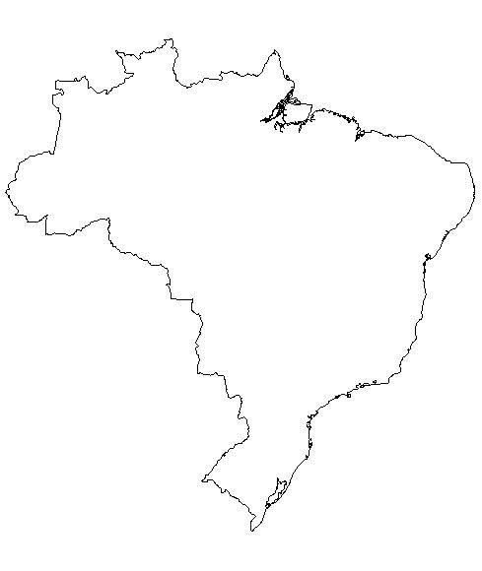 |  | This is the largest country in South America and makes up most of the east coast.  The capital is Brasilia
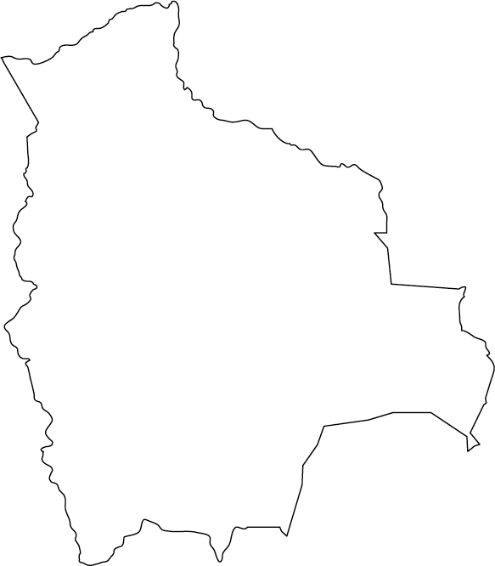 |  | This country is located in the center and is landlocked.  The capital is La Paz and Sucre
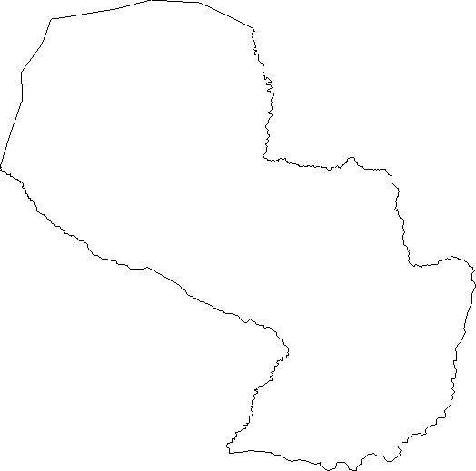 |  | This country is located in the center and is landlocked.  The capital is Asuncion
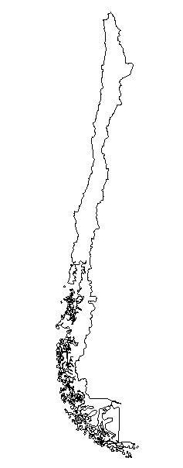 |  | This country makes up most of the south western coast.  The capital is Santiago
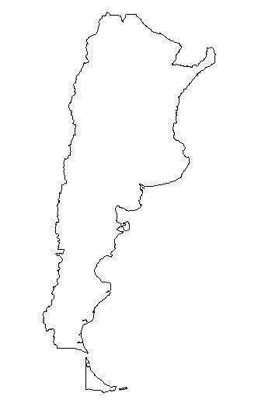 |  | This country is located in the south.  The capital is Buenos Aires
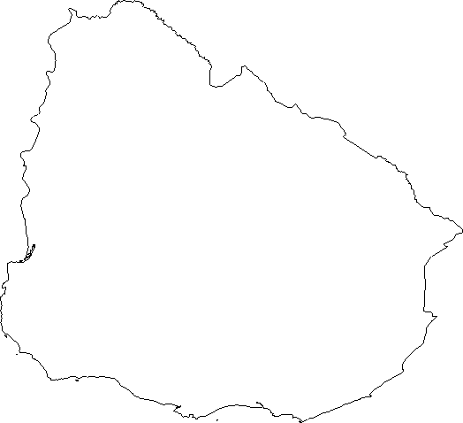 |  | This country is on the south eastern coast.  The capital is Montevideo

