The Surprise

Author Susie Hershberger
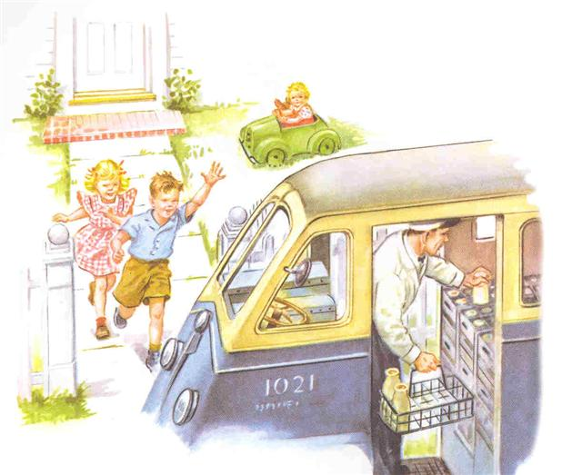
“Good Morning” said Fred and Carrie as the milkman brought their milk from his truck.

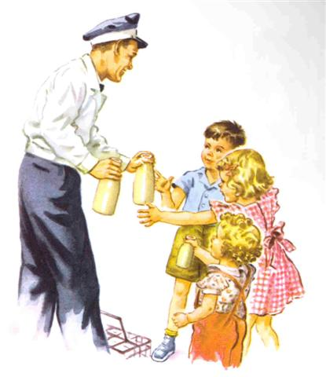

The milkman gave each of the children a bottle of milk to carry into the house.

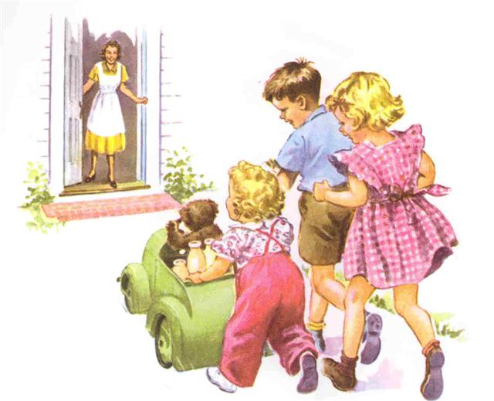
They delivered the milk to the door with Mary’s toy car. What fun to deliver the milk to mom!

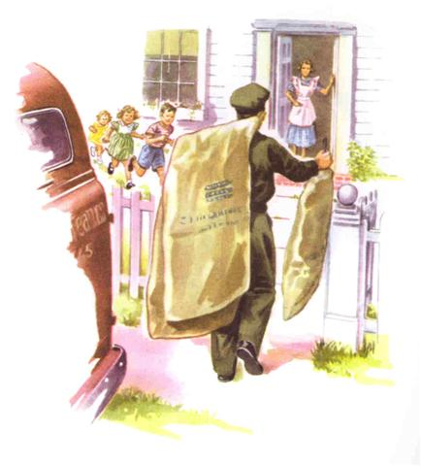
A little bit later, the mailman came with three big packages for Mom. Packages are like surprises!
What could be inside?
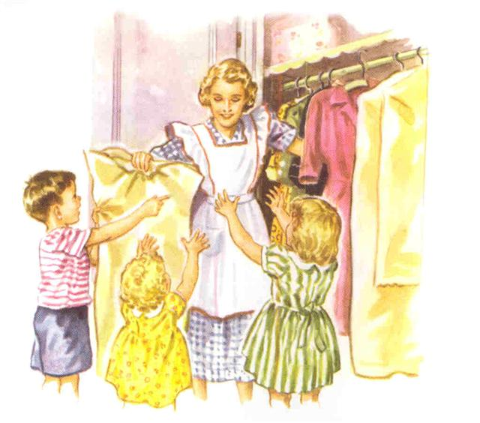
Mom took the bags off the new dresses she got in the mail.
“Would you like to play with the bags?” asked mom.
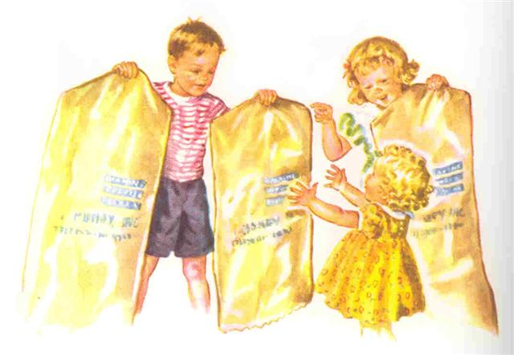
Fred, Carrie, and Mary were delighted! What fun!
“Let’s get inside the bags and be a surprise for Dad when he comes home!”
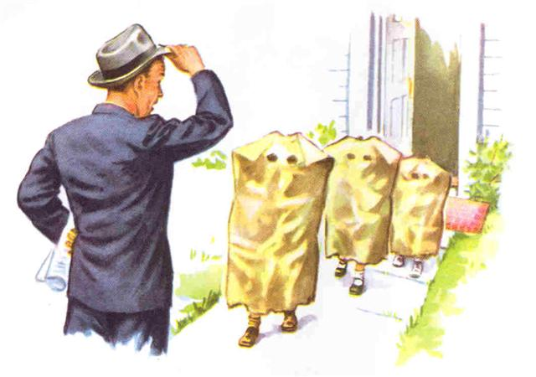
When Dad came home he saw three big bags walk out of his house!
“What are these funny looking things?” he asked.
“Surprise!” yelled the three children.

The End

