Stuck In A Tree

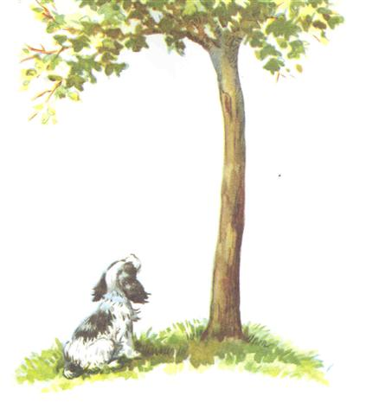

Author Dan Hoffman

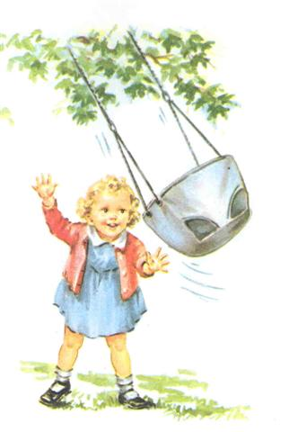

Baby Carol is playing in the back yard with her swing.

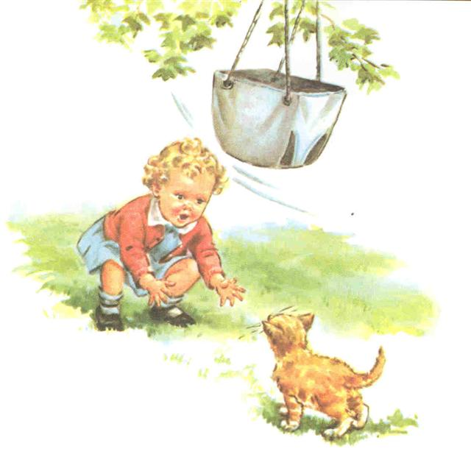

Baby Carol sees her kitten Fluffy. She calls to her, “Come Fluffy come” says Baby Carol.

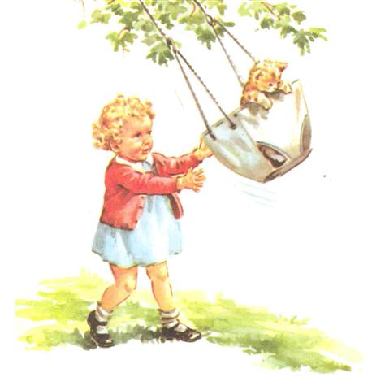

Baby Carol gives Fluffy a push on the swing.

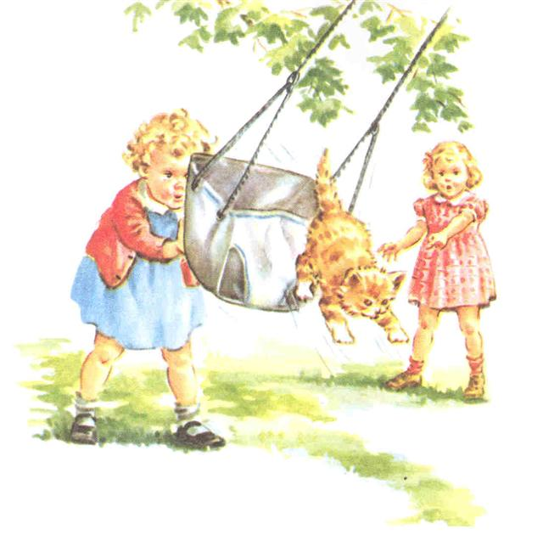

Fluffy jumps out of the swing. She runs fast and got away.

Fluffy runs right up a tree. Spot sees Fluffy run up the tree and barks to her to come down.

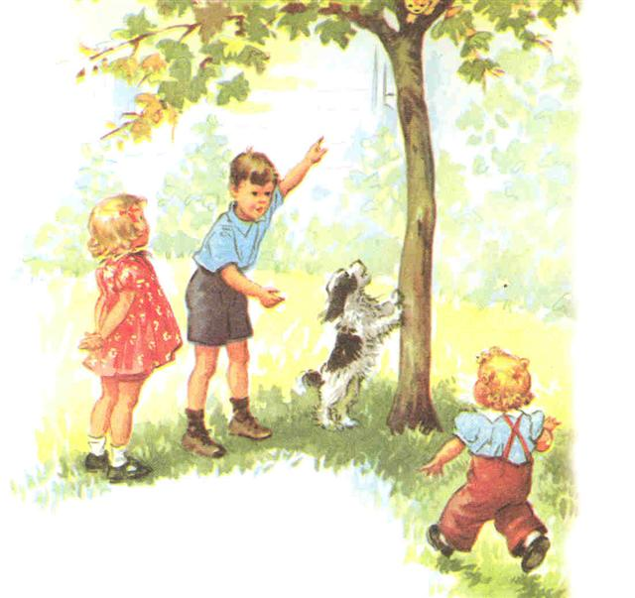

Baby Carol calls her brother and sister to help her get Fluffy down out of the tree.

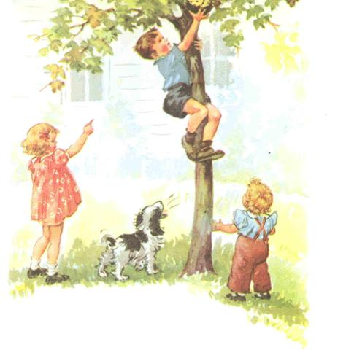

Jimmy climbs up the tree to help get Fluffy down.

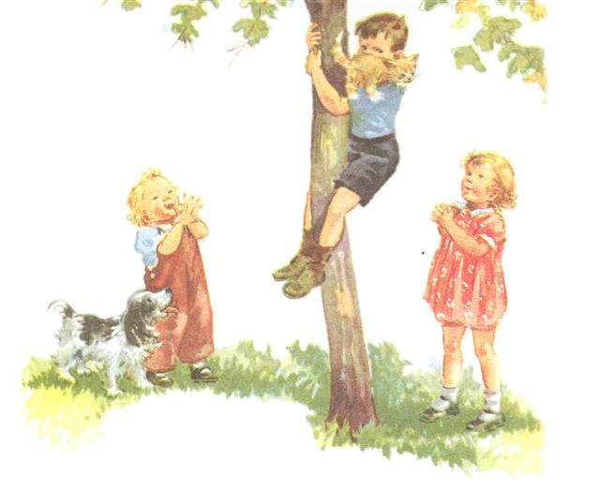
Jimmy climbs down out of the tree holding Fluffy. Jimmy is a hero, he saved Fluffy and saved the day.
Jimmy holds Fluff as he brings the kitten down out of the tree.

The End

