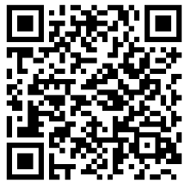
LESSON 1 COUNTING THE DOTS 0 – 5
SUBTRACTION
NAME __________________
Add the dots and place the number in the
Space provided. Scan the QR Code to check your
answers.
